De an chuyen nganh - Uoc luong mo hinh VAR du bao lam phat Viet Nam

11180815 - CHIEN NGUYEN MINH

5/3/2021

setwd("U:/Data Econ")  
data<-read.csv("data_dean.csv",header = 1)  
CPI=0;BY=0;M2=0;EX=0;OIL=0  
for(i in 0:34){  
 CPI[i+1]=mean(data$CPI[(1+3*i):(3+3*i)])  
 BY[i+1]=mean(data$BY[(1+3*i):(3+3*i)])  
 M2[i+1]=mean(data$M2[(1+3*i):(3+3*i)])  
 EX[i+1]=mean(data$EX[(1+3*i):(3+3*i)])  
 OIL[i+1]=mean(data$OIL[(1+3*i):(3+3*i)])  
}  
CPI=ts(CPI,start = c(2012,2),end = c(2020,4),frequency = 4)  
BY=ts(BY,start = c(2012,2),end = c(2020,4),frequency = 4) #Bond Yields  
M2=ts(M2,start = c(2012,2),end = c(2020,4),frequency = 4)  
EX=ts(EX,start = c(2012,2),end = c(2020,4),frequency = 4)  
OIL=ts(OIL,start = c(2012,2),end = c(2020,4),frequency = 4)  
#Load package  
library(vars)

## Loading required package: MASS

## Loading required package: strucchange

## Loading required package: zoo

##   
## Attaching package: 'zoo'

## The following objects are masked from 'package:base':  
##   
## as.Date, as.Date.numeric

## Loading required package: sandwich

## Loading required package: urca

## Loading required package: lmtest

library(VARtests)  
library(urca)  
library(forecast)

## Registered S3 method overwritten by 'quantmod':  
## method from  
## as.zoo.data.frame zoo

library(tseries)  
library(urca)  
library(FitAR)

## Loading required package: lattice

## Loading required package: leaps

## Loading required package: ltsa

## Loading required package: bestglm

##   
## Attaching package: 'FitAR'

## The following object is masked from 'package:forecast':  
##   
## BoxCox

library(FitARMA)

## Warning: package 'FitARMA' was built under R version 4.0.5

library(zoo)  
library(tsDyn)  
Series=cbind(log(CPI),BY,log(M2),log(EX),log(OIL))  
autoplot(Series, xlab="year", ylab="")

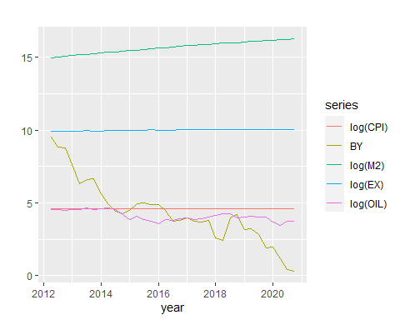 Nhan biet tinh thoi vu

#CPI  
autoplot(CPI, xlab="year", ylab="CPI")

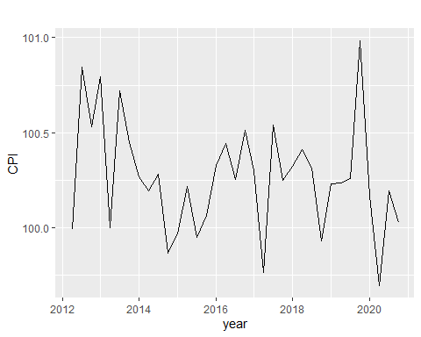

CPI_1=matrix(CPI, ncol=4, byrow= TRUE)

## Warning in matrix(CPI, ncol = 4, byrow = TRUE): data length [35] is not a sub-  
## multiple or multiple of the number of rows [9]

col.means=apply(CPI_1,2,mean)  
plot(col.means,type="b", main="Quarterly Means Plot", xlab="Quarterly", ylab="Mean")

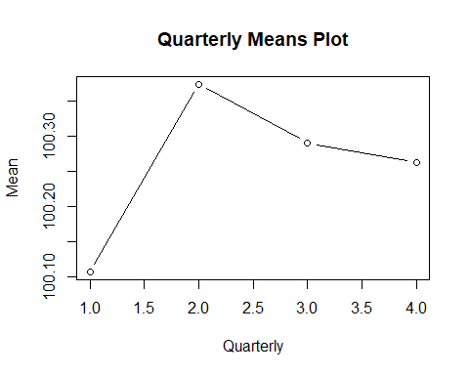

autoplot(decompose(CPI, type = c("additive"), filter = NULL))

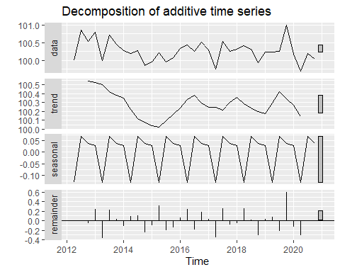

autoplot(decompose(CPI, type = c("multiplicative"), filter = NULL))

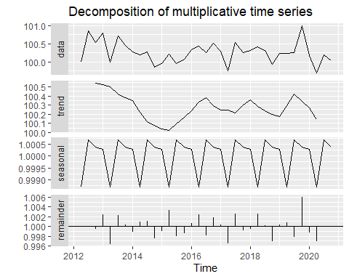

#BY  
autoplot(BY, xlab="year", ylab="Bond Yield")

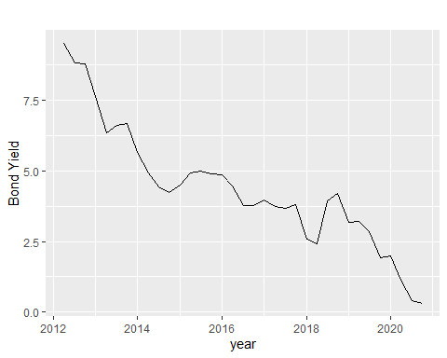

BY_1=matrix(BY, ncol=4, byrow= TRUE)

## Warning in matrix(BY, ncol = 4, byrow = TRUE): data length [35] is not a sub-  
## multiple or multiple of the number of rows [9]

col.means1=apply(BY_1,2,mean)  
plot(col.means1,type="b", main="Quarterly Means Plot", xlab="Quarterly", ylab="Mean")

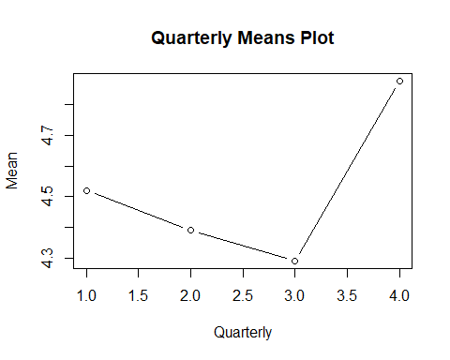

autoplot(decompose(BY, type = c("additive"), filter = NULL))

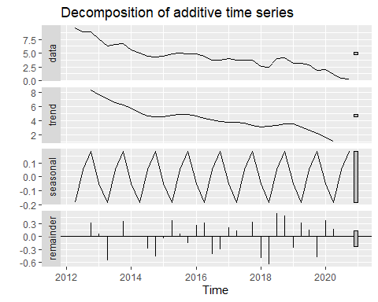

autoplot(decompose(BY, type = c("multiplicative"), filter = NULL))

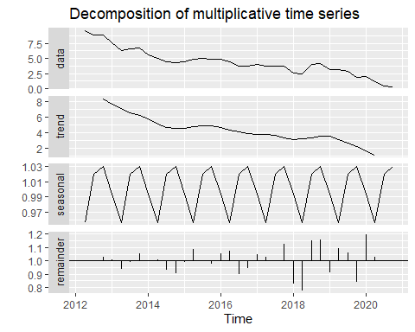

#M2  
autoplot(M2, xlab="year", ylab="M2")

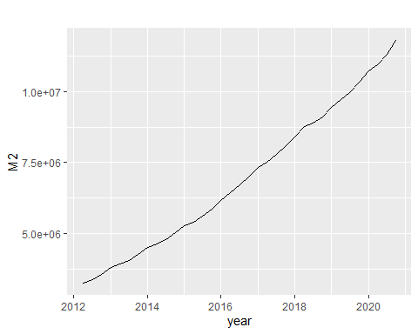

M2_1=matrix(M2, ncol=4, byrow= TRUE)

## Warning in matrix(M2, ncol = 4, byrow = TRUE): data length [35] is not a sub-  
## multiple or multiple of the number of rows [9]

col.means2=apply(M2_1,2,mean)  
plot(col.means2,type="b", main="Quarterly Means Plot", xlab="Quarterly", ylab="Mean")

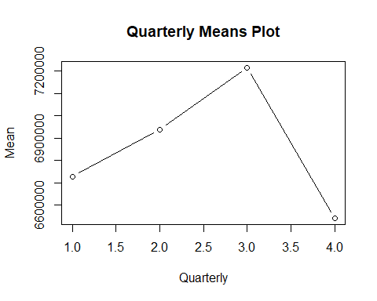

autoplot(decompose(M2, type = c("additive"), filter = NULL))

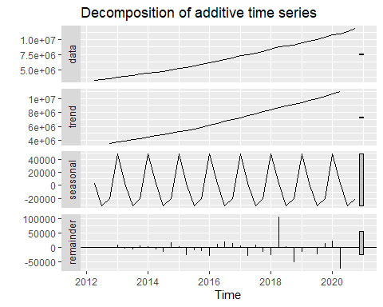

autoplot(decompose(M2, type = c("multiplicative"), filter = NULL))

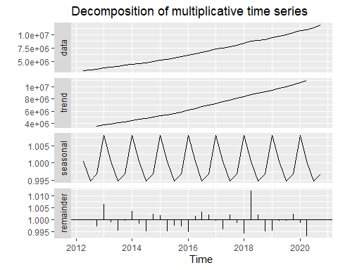

#EX  
autoplot(EX, xlab="year", ylab="Exchange Rate USD/VND")

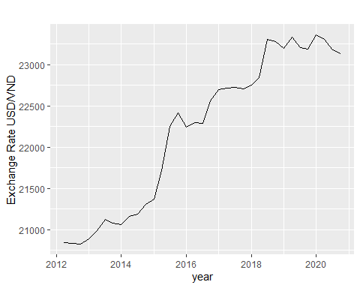

EX_1=matrix(EX, ncol=4, byrow= TRUE)

## Warning in matrix(EX, ncol = 4, byrow = TRUE): data length [35] is not a sub-  
## multiple or multiple of the number of rows [9]

col.means3=apply(EX_1,2,mean)  
plot(col.means3,type="b", main="Quarterly Means Plot", xlab="Quarterly", ylab="Mean")

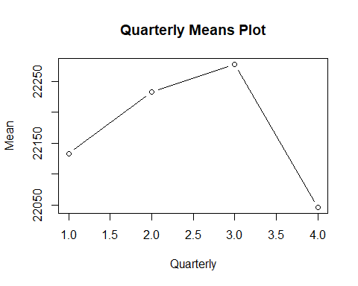

autoplot(decompose(EX, type = c("additive"), filter = NULL))

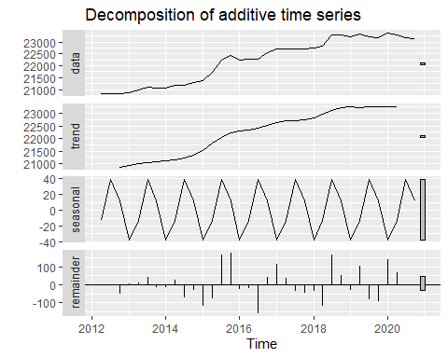

autoplot(decompose(EX, type = c("multiplicative"), filter = NULL))

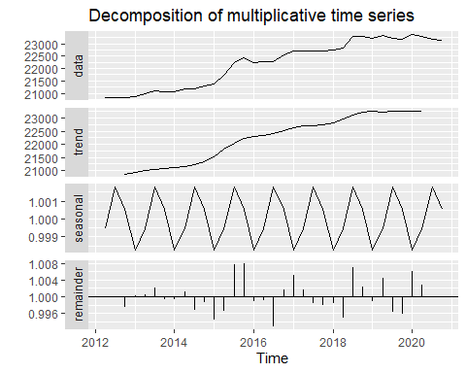

#OIL  
autoplot(OIL, xlab="year", ylab="WTI oil price")

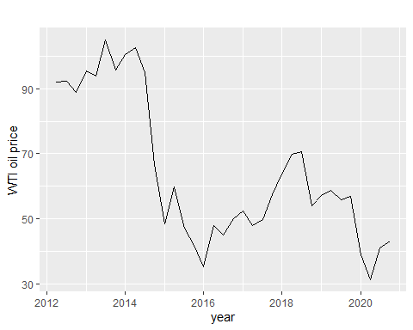

OIL_1=matrix(OIL, ncol=4, byrow= TRUE)

## Warning in matrix(OIL, ncol = 4, byrow = TRUE): data length [35] is not a sub-  
## multiple or multiple of the number of rows [9]

col.means4=apply(OIL_1,2,mean)  
plot(col.means4,type="b", main="Quarterly Means Plot", xlab="Quarterly", ylab="Mean")

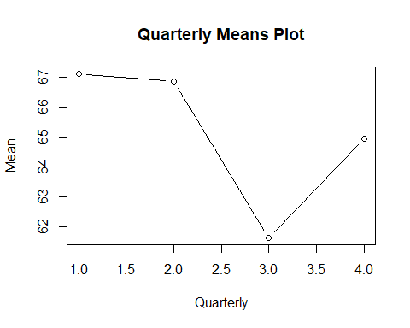

autoplot(decompose(OIL, type = c("additive"), filter = NULL))

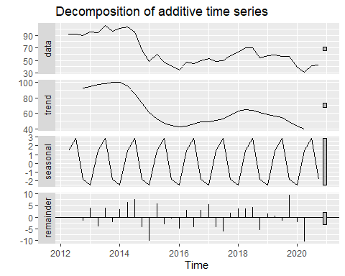

autoplot(decompose(OIL, type = c("multiplicative"), filter = NULL))

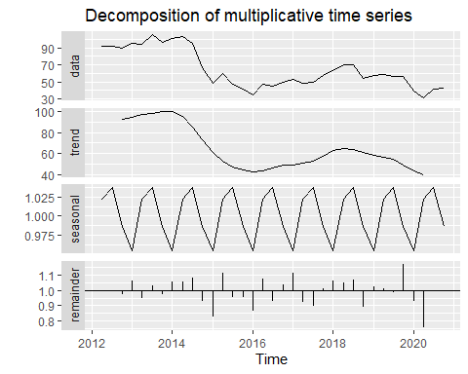

Unit root test

#log(CPI) I(0)  
ts.plot(log(CPI))

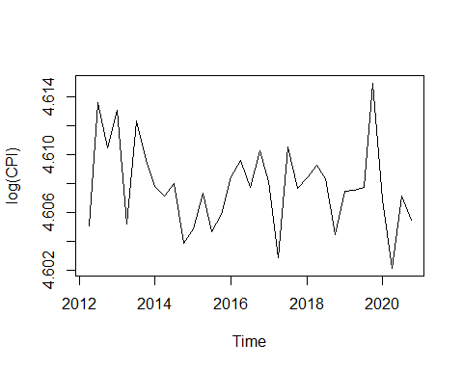

summary(ur.df(log(CPI), type = c("drift"), selectlags="AIC"))

##   
## ###############################################   
## # Augmented Dickey-Fuller Test Unit Root Test #   
## ###############################################   
##   
## Test regression drift   
##   
##   
## Call:  
## lm(formula = z.diff ~ z.lag.1 + 1 + z.diff.lag)  
##   
## Residuals:  
## Min 1Q Median 3Q Max   
## -0.0056573 -0.0016281 -0.0000729 0.0015319 0.0072444   
##   
## Coefficients:  
## Estimate Std. Error t value Pr(>|t|)   
## (Intercept) 4.15452 1.11170 3.737 0.000782 ***  
## z.lag.1 -0.90165 0.24126 -3.737 0.000782 ***  
## z.diff.lag -0.02011 0.17045 -0.118 0.906863   
## ---  
## Signif. codes: 0 '***' 0.001 '**' 0.01 '*' 0.05 '.' 0.1 ' ' 1  
##   
## Residual standard error: 0.002881 on 30 degrees of freedom  
## Multiple R-squared: 0.4869, Adjusted R-squared: 0.4527   
## F-statistic: 14.23 on 2 and 30 DF, p-value: 4.5e-05  
##   
##   
## Value of test-statistic is: -3.7373 7.0775   
##   
## Critical values for test statistics:   
## 1pct 5pct 10pct  
## tau2 -3.58 -2.93 -2.60  
## phi1 7.06 4.86 3.94

adf.test(log(CPI))

##   
## Augmented Dickey-Fuller Test  
##   
## data: log(CPI)  
## Dickey-Fuller = -2.9044, Lag order = 3, p-value = 0.2219  
## alternative hypothesis: stationary

acf(log(CPI), lag.max = 10, plot=TRUE,na.action = na.contiguous)

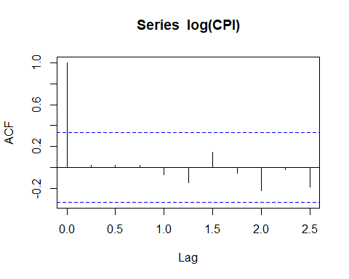

pacf(log(CPI), lag.max = 10, plot=TRUE,na.action = na.contiguous)

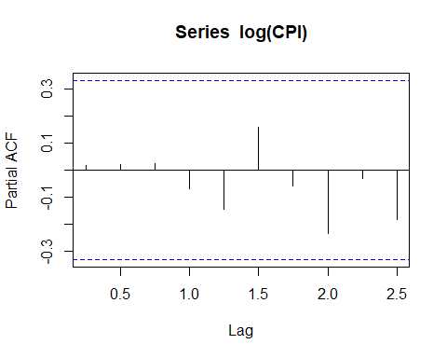

#BY I(1)  
ts.plot(BY)

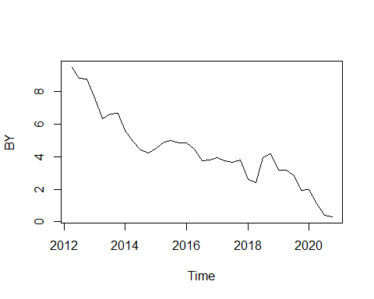

ts.plot(diff(BY))

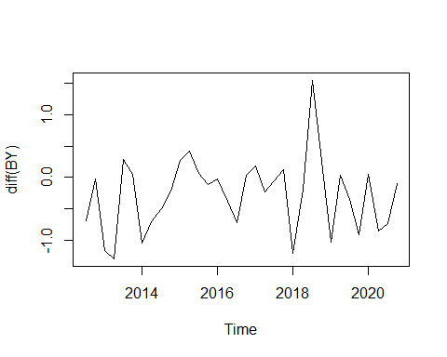

summary(ur.df(diff(BY), type = c("drift"), selectlags="AIC"))

##   
## ###############################################   
## # Augmented Dickey-Fuller Test Unit Root Test #   
## ###############################################   
##   
## Test regression drift   
##   
##   
## Call:  
## lm(formula = z.diff ~ z.lag.1 + 1 + z.diff.lag)  
##   
## Residuals:  
## Min 1Q Median 3Q Max   
## -1.09945 -0.36750 0.04613 0.37132 1.42729   
##   
## Coefficients:  
## Estimate Std. Error t value Pr(>|t|)   
## (Intercept) -0.3297 0.1161 -2.839 0.00818 **   
## z.lag.1 -1.2460 0.2280 -5.464 6.98e-06 ***  
## z.diff.lag 0.3954 0.1707 2.316 0.02781 *   
## ---  
## Signif. codes: 0 '***' 0.001 '**' 0.01 '*' 0.05 '.' 0.1 ' ' 1  
##   
## Residual standard error: 0.563 on 29 degrees of freedom  
## Multiple R-squared: 0.5332, Adjusted R-squared: 0.501   
## F-statistic: 16.56 on 2 and 29 DF, p-value: 1.594e-05  
##   
##   
## Value of test-statistic is: -5.4645 14.9307   
##   
## Critical values for test statistics:   
## 1pct 5pct 10pct  
## tau2 -3.58 -2.93 -2.60  
## phi1 7.06 4.86 3.94

acf(diff(BY), lag.max = 10, plot=TRUE,na.action = na.contiguous)

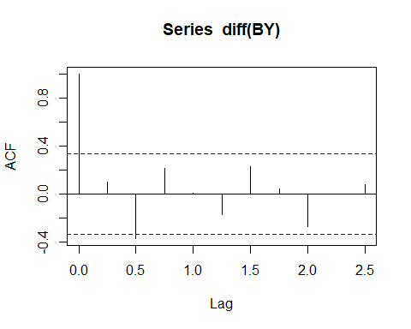

pacf(diff(BY), lag.max = 10, plot=TRUE,na.action = na.contiguous)

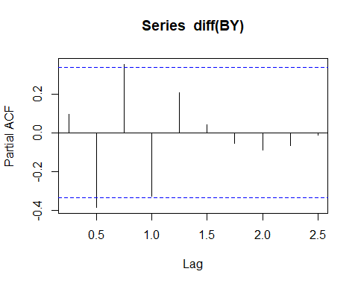

#log(M2) I(1)  
ts.plot(diff(log(M2)))

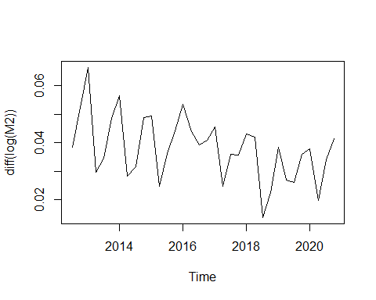

summary(ur.df(diff(log(M2)), type = c("drift"), selectlags="AIC"))

##   
## ###############################################   
## # Augmented Dickey-Fuller Test Unit Root Test #   
## ###############################################   
##   
## Test regression drift   
##   
##   
## Call:  
## lm(formula = z.diff ~ z.lag.1 + 1 + z.diff.lag)  
##   
## Residuals:  
## Min 1Q Median 3Q Max   
## -0.023187 -0.007900 0.002139 0.005894 0.025259   
##   
## Coefficients:  
## Estimate Std. Error t value Pr(>|t|)   
## (Intercept) 0.039271 0.008505 4.617 7.34e-05 ***  
## z.lag.1 -1.045958 0.218575 -4.785 4.61e-05 ***  
## z.diff.lag 0.297528 0.172735 1.722 0.0956 .   
## ---  
## Signif. codes: 0 '***' 0.001 '**' 0.01 '*' 0.05 '.' 0.1 ' ' 1  
##   
## Residual standard error: 0.01086 on 29 degrees of freedom  
## Multiple R-squared: 0.4706, Adjusted R-squared: 0.4341   
## F-statistic: 12.89 on 2 and 29 DF, p-value: 9.887e-05  
##   
##   
## Value of test-statistic is: -4.7853 11.4692   
##   
## Critical values for test statistics:   
## 1pct 5pct 10pct  
## tau2 -3.58 -2.93 -2.60  
## phi1 7.06 4.86 3.94

acf(diff(log(M2)), lag.max = 10, plot=TRUE,na.action = na.contiguous)

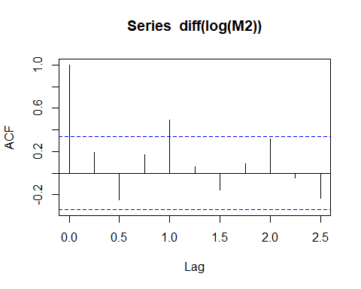

pacf(diff(log(M2)), lag.max = 10, plot=TRUE,na.action = na.contiguous)

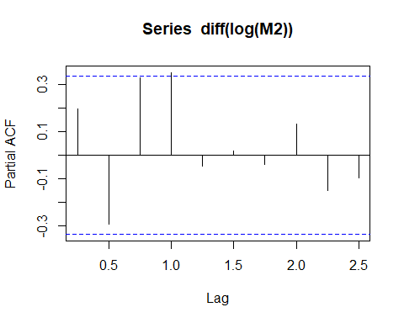

#log(EX) I(1)  
ts.plot(diff(log(EX)))

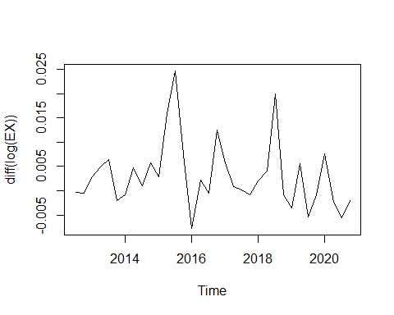

summary(ur.df(diff(log(EX)), type = c("drift"), selectlags="AIC"))

##   
## ###############################################   
## # Augmented Dickey-Fuller Test Unit Root Test #   
## ###############################################   
##   
## Test regression drift   
##   
##   
## Call:  
## lm(formula = z.diff ~ z.lag.1 + 1 + z.diff.lag)  
##   
## Residuals:  
## Min 1Q Median 3Q Max   
## -0.011219 -0.004004 -0.000969 0.002661 0.017721   
##   
## Coefficients:  
## Estimate Std. Error t value Pr(>|t|)   
## (Intercept) 0.003271 0.001451 2.255 0.031887 *   
## z.lag.1 -0.984738 0.228581 -4.308 0.000172 ***  
## z.diff.lag 0.262361 0.183564 1.429 0.163613   
## ---  
## Signif. codes: 0 '***' 0.001 '**' 0.01 '*' 0.05 '.' 0.1 ' ' 1  
##   
## Residual standard error: 0.006923 on 29 degrees of freedom  
## Multiple R-squared: 0.4262, Adjusted R-squared: 0.3867   
## F-statistic: 10.77 on 2 and 29 DF, p-value: 0.0003174  
##   
##   
## Value of test-statistic is: -4.308 9.282   
##   
## Critical values for test statistics:   
## 1pct 5pct 10pct  
## tau2 -3.58 -2.93 -2.60  
## phi1 7.06 4.86 3.94

summary(ur.df(diff(log(EX)), type = c("none"), selectlags="AIC"))

##   
## ###############################################   
## # Augmented Dickey-Fuller Test Unit Root Test #   
## ###############################################   
##   
## Test regression none   
##   
##   
## Call:  
## lm(formula = z.diff ~ z.lag.1 - 1 + z.diff.lag)  
##   
## Residuals:  
## Min 1Q Median 3Q Max   
## -0.0085408 -0.0009374 0.0006833 0.0051697 0.0186232   
##   
## Coefficients:  
## Estimate Std. Error t value Pr(>|t|)   
## z.lag.1 -0.7081 0.2056 -3.445 0.00171 **  
## z.diff.lag 0.1151 0.1828 0.629 0.53384   
## ---  
## Signif. codes: 0 '***' 0.001 '**' 0.01 '*' 0.05 '.' 0.1 ' ' 1  
##   
## Residual standard error: 0.007379 on 30 degrees of freedom  
## Multiple R-squared: 0.3257, Adjusted R-squared: 0.2807   
## F-statistic: 7.245 on 2 and 30 DF, p-value: 0.00271  
##   
##   
## Value of test-statistic is: -3.4447   
##   
## Critical values for test statistics:   
## 1pct 5pct 10pct  
## tau1 -2.62 -1.95 -1.61

acf(diff(log(EX)), lag.max = 10, plot=TRUE,na.action = na.contiguous)

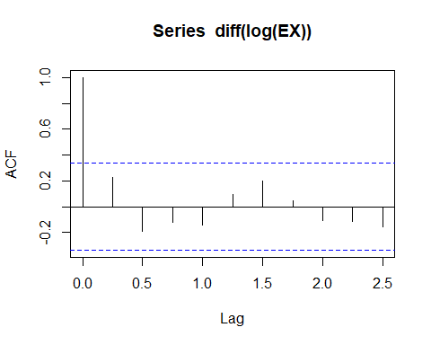

pacf(diff(log(EX)), lag.max = 10, plot=TRUE,na.action = na.contiguous)

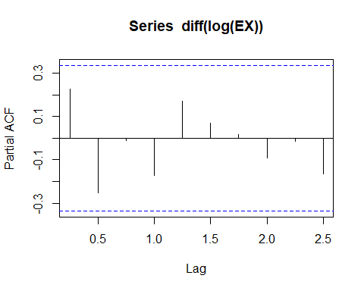

#log(OIL) I(1)  
ts.plot(diff(log(OIL)))

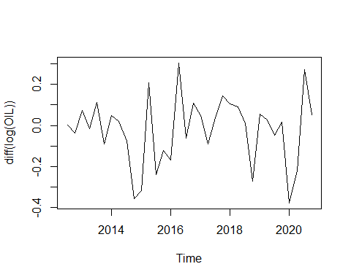

summary(ur.df(diff(log(OIL)), type = c("drift"), selectlags="AIC"))

##   
## ###############################################   
## # Augmented Dickey-Fuller Test Unit Root Test #   
## ###############################################   
##   
## Test regression drift   
##   
##   
## Call:  
## lm(formula = z.diff ~ z.lag.1 + 1 + z.diff.lag)  
##   
## Residuals:  
## Min 1Q Median 3Q Max   
## -0.35683 -0.06526 0.04098 0.10908 0.31366   
##   
## Coefficients:  
## Estimate Std. Error t value Pr(>|t|)   
## (Intercept) -0.02759 0.03191 -0.865 0.394244   
## z.lag.1 -1.15018 0.27250 -4.221 0.000219 ***  
## z.diff.lag 0.14333 0.19486 0.736 0.467917   
## ---  
## Signif. codes: 0 '***' 0.001 '**' 0.01 '*' 0.05 '.' 0.1 ' ' 1  
##   
## Residual standard error: 0.1744 on 29 degrees of freedom  
## Multiple R-squared: 0.509, Adjusted R-squared: 0.4751   
## F-statistic: 15.03 on 2 and 29 DF, p-value: 3.321e-05  
##   
##   
## Value of test-statistic is: -4.2208 8.931   
##   
## Critical values for test statistics:   
## 1pct 5pct 10pct  
## tau2 -3.58 -2.93 -2.60  
## phi1 7.06 4.86 3.94

summary(ur.df(diff(log(OIL)), type = c("none"), selectlags="AIC"))

##   
## ###############################################   
## # Augmented Dickey-Fuller Test Unit Root Test #   
## ###############################################   
##   
## Test regression none   
##   
##   
## Call:  
## lm(formula = z.diff ~ z.lag.1 - 1 + z.diff.lag)  
##   
## Residuals:  
## Min 1Q Median 3Q Max   
## -0.38312 -0.09460 0.01449 0.08068 0.29452   
##   
## Coefficients:  
## Estimate Std. Error t value Pr(>|t|)   
## z.lag.1 -1.0902 0.2624 -4.154 0.000249 ***  
## z.diff.lag 0.1078 0.1897 0.568 0.574169   
## ---  
## Signif. codes: 0 '***' 0.001 '**' 0.01 '*' 0.05 '.' 0.1 ' ' 1  
##   
## Residual standard error: 0.1737 on 30 degrees of freedom  
## Multiple R-squared: 0.4964, Adjusted R-squared: 0.4628   
## F-statistic: 14.78 on 2 and 30 DF, p-value: 3.403e-05  
##   
##   
## Value of test-statistic is: -4.1544   
##   
## Critical values for test statistics:   
## 1pct 5pct 10pct  
## tau1 -2.62 -1.95 -1.61

acf(diff(log(OIL)), lag.max = 10, plot=TRUE,na.action = na.contiguous)

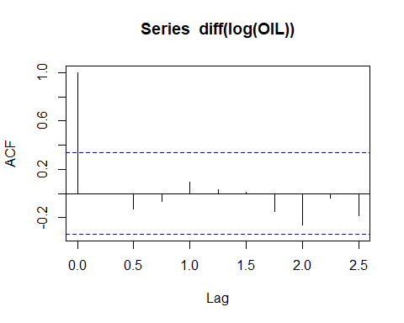

pacf(diff(log(OIL)), lag.max = 10, plot=TRUE,na.action = na.contiguous)

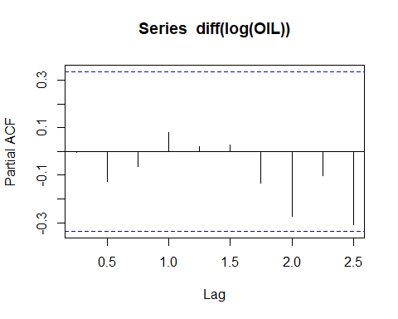 Uoc luong mo hinh VAR

#Uoc luong VAR  
dlnCPI=diff(log(CPI))  
dBY=diff(BY)  
dlnM2=diff(log(M2))  
dlnEX=diff(log(EX))  
dlnOIL=diff(log(OIL))  
Series1<-cbind(dlnCPI,dlnM2,dlnOIL)  
Series1

## dlnCPI dlnM2 dlnOIL  
## 2012 Q3 8.531030e-03 0.03834425 0.001301801  
## 2012 Q4 -3.145021e-03 0.05243502 -0.035869872  
## 2013 Q1 2.616025e-03 0.06631248 0.071544208  
## 2013 Q2 -7.868697e-03 0.02970766 -0.016808891  
## 2013 Q3 7.140871e-03 0.03459794 0.110732775  
## 2013 Q4 -2.717483e-03 0.04847205 -0.091311961  
## 2014 Q1 -1.793603e-03 0.05632031 0.048008132  
## 2014 Q2 -7.316506e-04 0.02828167 0.020214641  
## 2014 Q3 8.978602e-04 0.03147286 -0.076008990  
## 2014 Q4 -4.163550e-03 0.04870839 -0.355388860  
## 2015 Q1 1.000834e-03 0.04931669 -0.317254211  
## 2015 Q2 2.497712e-03 0.02477593 0.208754814  
## 2015 Q3 -2.664448e-03 0.03611271 -0.237954477  
## 2015 Q4 1.166570e-03 0.04420538 -0.121112240  
## 2016 Q1 2.628122e-03 0.05338605 -0.169851736  
## 2016 Q2 1.128968e-03 0.04393739 0.304589697  
## 2016 Q3 -1.860157e-03 0.03929924 -0.063427640  
## 2016 Q4 2.556824e-03 0.04083960 0.108907066  
## 2017 Q1 -2.124694e-03 0.04547215 0.048148774  
## 2017 Q2 -5.331569e-03 0.02482231 -0.091259191  
## 2017 Q3 7.721532e-03 0.03591303 0.036757793  
## 2017 Q4 -2.888592e-03 0.03571858 0.144240598  
## 2018 Q1 7.312372e-04 0.04304487 0.105238557  
## 2018 Q2 8.966972e-04 0.04190713 0.092068871  
## 2018 Q3 -9.631512e-04 0.01381920 0.009725626  
## 2018 Q4 -3.861908e-03 0.02255318 -0.270256142  
## 2019 Q1 2.997604e-03 0.03849421 0.057106861  
## 2019 Q2 6.651147e-05 0.02704890 0.027261579  
## 2019 Q3 2.327553e-04 0.02619816 -0.047327168  
## 2019 Q4 7.188675e-03 0.03595523 0.015732522  
## 2020 Q1 -8.092401e-03 0.03796844 -0.377744228  
## 2020 Q2 -4.730843e-03 0.01969764 -0.221432687  
## 2020 Q3 5.002679e-03 0.03409247 0.273966650  
## 2020 Q4 -1.664780e-03 0.04129600 0.051841479

VARselect(Series1, lag.max = 20,type="const")

## $selection  
## AIC(n) HQ(n) SC(n) FPE(n)   
## 4 4 4 4   
##   
## $criteria  
## 1 2 3 4 5 6 7 8 9  
## AIC(n) -2.366814e+01 -2.360365e+01 -2.311911e+01 -Inf -Inf -Inf -Inf -Inf -Inf  
## HQ(n) -2.371885e+01 -2.369238e+01 -2.324587e+01 -Inf -Inf -Inf -Inf -Inf -Inf  
## SC(n) -2.312038e+01 -2.264506e+01 -2.174970e+01 -Inf -Inf -Inf -Inf -Inf -Inf  
## FPE(n) 5.525481e-11 7.543058e-11 2.708253e-10 0 0 0 0 0 0  
## 10 11 12 13 14 15 16 17 18 19 20  
## AIC(n) -Inf -Inf -Inf -Inf -Inf -Inf -Inf -Inf -Inf -Inf -Inf  
## HQ(n) -Inf -Inf -Inf -Inf -Inf -Inf -Inf -Inf -Inf -Inf -Inf  
## SC(n) -Inf -Inf -Inf -Inf -Inf -Inf -Inf -Inf -Inf -Inf -Inf  
## FPE(n) 0 0 0 0 0 0 0 0 0 0 0

var1 = VAR(Series1, p=4,type = "const",ic = c("AIC"))  
summary(var1)

##   
## VAR Estimation Results:  
## =========================   
## Endogenous variables: dlnCPI, dlnM2, dlnOIL   
## Deterministic variables: const   
## Sample size: 30   
## Log Likelihood: 276.734   
## Roots of the characteristic polynomial:  
## 0.9863 0.9863 0.9082 0.9082 0.8869 0.8301 0.8301 0.7777 0.6796 0.6796 0.578 0.578  
## Call:  
## VAR(y = Series1, p = 4, type = "const", ic = c("AIC"))  
##   
##   
## Estimation results for equation dlnCPI:   
## =======================================   
## dlnCPI = dlnCPI.l1 + dlnM2.l1 + dlnOIL.l1 + dlnCPI.l2 + dlnM2.l2 + dlnOIL.l2 + dlnCPI.l3 + dlnM2.l3 + dlnOIL.l3 + dlnCPI.l4 + dlnM2.l4 + dlnOIL.l4 + const   
##   
## Estimate Std. Error t value Pr(>|t|)   
## dlnCPI.l1 -0.6630453 0.2587019 -2.563 0.0202 *  
## dlnM2.l1 0.0009939 0.0754498 0.013 0.9896   
## dlnOIL.l1 -0.0026173 0.0045797 -0.571 0.5751   
## dlnCPI.l2 -0.9012002 0.3146731 -2.864 0.0108 *  
## dlnM2.l2 0.0735345 0.0798850 0.921 0.3702   
## dlnOIL.l2 0.0072337 0.0053082 1.363 0.1907   
## dlnCPI.l3 -0.5403276 0.3704706 -1.458 0.1629   
## dlnM2.l3 -0.0798511 0.0818568 -0.975 0.3430   
## dlnOIL.l3 0.0009776 0.0052638 0.186 0.8549   
## dlnCPI.l4 -0.0685731 0.2275855 -0.301 0.7668   
## dlnM2.l4 -0.0711984 0.0804594 -0.885 0.3886   
## dlnOIL.l4 -0.0128359 0.0046637 -2.752 0.0136 *  
## const 0.0025637 0.0039470 0.650 0.5247   
## ---  
## Signif. codes: 0 '***' 0.001 '**' 0.01 '*' 0.05 '.' 0.1 ' ' 1  
##   
##   
## Residual standard error: 0.003031 on 17 degrees of freedom  
## Multiple R-Squared: 0.6177, Adjusted R-squared: 0.3478   
## F-statistic: 2.289 on 12 and 17 DF, p-value: 0.05797   
##   
##   
## Estimation results for equation dlnM2:   
## ======================================   
## dlnM2 = dlnCPI.l1 + dlnM2.l1 + dlnOIL.l1 + dlnCPI.l2 + dlnM2.l2 + dlnOIL.l2 + dlnCPI.l3 + dlnM2.l3 + dlnOIL.l3 + dlnCPI.l4 + dlnM2.l4 + dlnOIL.l4 + const   
##   
## Estimate Std. Error t value Pr(>|t|)   
## dlnCPI.l1 0.284308 0.742644 0.383 0.7066   
## dlnM2.l1 0.084261 0.216590 0.389 0.7021   
## dlnOIL.l1 -0.004568 0.013147 -0.347 0.7325   
## dlnCPI.l2 -0.062749 0.903318 -0.069 0.9454   
## dlnM2.l2 -0.065077 0.229322 -0.284 0.7800   
## dlnOIL.l2 -0.004974 0.015238 -0.326 0.7481   
## dlnCPI.l3 -0.138782 1.063494 -0.130 0.8977   
## dlnM2.l3 0.082393 0.234983 0.351 0.7302   
## dlnOIL.l3 -0.011493 0.015111 -0.761 0.4573   
## dlnCPI.l4 -0.306531 0.653320 -0.469 0.6449   
## dlnM2.l4 0.535258 0.230971 2.317 0.0332 *  
## dlnOIL.l4 -0.021853 0.013388 -1.632 0.1210   
## const 0.011456 0.011330 1.011 0.3261   
## ---  
## Signif. codes: 0 '***' 0.001 '**' 0.01 '*' 0.05 '.' 0.1 ' ' 1  
##   
##   
## Residual standard error: 0.008702 on 17 degrees of freedom  
## Multiple R-Squared: 0.5736, Adjusted R-squared: 0.2727   
## F-statistic: 1.906 on 12 and 17 DF, p-value: 0.109   
##   
##   
## Estimation results for equation dlnOIL:   
## =======================================   
## dlnOIL = dlnCPI.l1 + dlnM2.l1 + dlnOIL.l1 + dlnCPI.l2 + dlnM2.l2 + dlnOIL.l2 + dlnCPI.l3 + dlnM2.l3 + dlnOIL.l3 + dlnCPI.l4 + dlnM2.l4 + dlnOIL.l4 + const   
##   
## Estimate Std. Error t value Pr(>|t|)  
## dlnCPI.l1 -24.23323 15.92914 -1.521 0.147  
## dlnM2.l1 7.57849 4.64570 1.631 0.121  
## dlnOIL.l1 0.19136 0.28199 0.679 0.507  
## dlnCPI.l2 -27.07514 19.37547 -1.397 0.180  
## dlnM2.l2 -1.73780 4.91878 -0.353 0.728  
## dlnOIL.l2 0.09635 0.32684 0.295 0.772  
## dlnCPI.l3 -7.18141 22.81112 -0.315 0.757  
## dlnM2.l3 0.51151 5.04019 0.101 0.920  
## dlnOIL.l3 -0.04108 0.32411 -0.127 0.901  
## dlnCPI.l4 8.71270 14.01320 0.622 0.542  
## dlnM2.l4 -5.59501 4.95416 -1.129 0.274  
## dlnOIL.l4 0.01616 0.28716 0.056 0.956  
## const -0.04948 0.24303 -0.204 0.841  
##   
##   
## Residual standard error: 0.1867 on 17 degrees of freedom  
## Multiple R-Squared: 0.3343, Adjusted R-squared: -0.1355   
## F-statistic: 0.7115 on 12 and 17 DF, p-value: 0.722   
##   
##   
##   
## Covariance matrix of residuals:  
## dlnCPI dlnM2 dlnOIL  
## dlnCPI 9.189e-06 1.126e-05 0.0003831  
## dlnM2 1.126e-05 7.573e-05 0.0004307  
## dlnOIL 3.831e-04 4.307e-04 0.0348393  
##   
## Correlation matrix of residuals:  
## dlnCPI dlnM2 dlnOIL  
## dlnCPI 1.0000 0.4269 0.6771  
## dlnM2 0.4269 1.0000 0.2652  
## dlnOIL 0.6771 0.2652 1.0000

#Test for residual  
##White Noise  
residual_var1=resid(var1)  
residual_var1

## dlnCPI dlnM2 dlnOIL  
## 1 2.104573e-03 0.0045844153 0.016082043  
## 2 2.506232e-04 -0.0001607504 -0.002819302  
## 3 5.999051e-04 0.0075235148 0.199230031  
## 4 -1.895138e-03 -0.0039290747 -0.117151297  
## 5 -1.365519e-03 0.0023946378 -0.136268839  
## 6 -3.673555e-03 0.0027815282 -0.224099594  
## 7 8.894356e-05 0.0031967281 -0.272402241  
## 8 2.505707e-04 -0.0096915361 0.127117592  
## 9 -1.660315e-04 -0.0024011404 -0.112214365  
## 10 -1.493901e-03 -0.0105007598 0.009688757  
## 11 -2.269252e-04 0.0060003504 -0.104224224  
## 12 4.778407e-03 0.0147930503 0.231850010  
## 13 3.622761e-04 -0.0022134121 0.012336905  
## 14 1.659637e-03 -0.0011803543 0.128898570  
## 15 -1.234366e-03 0.0010259366 0.129969802  
## 16 -1.399576e-03 -0.0070225762 -0.122385485  
## 17 2.144849e-03 0.0017793417 0.042293035  
## 18 6.748247e-04 -0.0021486270 0.177130724  
## 19 3.546552e-03 0.0052909092 0.271765476  
## 20 1.155289e-05 0.0115772346 0.008275140  
## 21 -1.291933e-03 -0.0153709654 -0.069843216  
## 22 -2.066150e-03 -0.0055957424 -0.052237848  
## 23 3.395513e-03 0.0031015726 0.112345111  
## 24 1.218261e-03 -0.0096661947 0.018977517  
## 25 -1.763620e-03 0.0025656168 -0.028712484  
## 26 5.012685e-03 0.0026481166 0.095924241  
## 27 -1.410156e-03 0.0026508597 -0.197074662  
## 28 -5.421608e-03 -0.0080458867 -0.191272457  
## 29 -6.356376e-04 0.0046243031 0.164363541  
## 30 -2.055058e-03 0.0013889042 -0.115542482

acf(residual_var1[,"dlnCPI"])

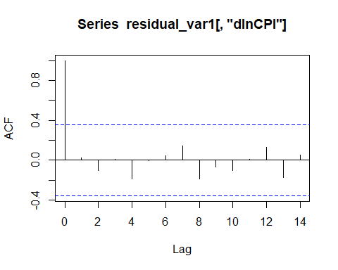

acf(residual_var1[,"dlnM2"])

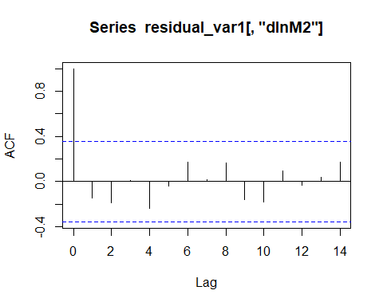

acf(residual_var1[,"dlnOIL"])

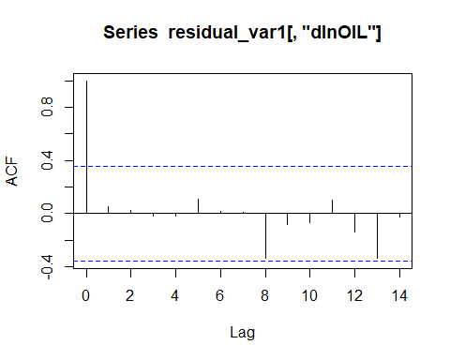

#Serial Correlation  
serial.test(var1, lags.pt = 8, type="PT.asymptotic")

##   
## Portmanteau Test (asymptotic)  
##   
## data: Residuals of VAR object var1  
## Chi-squared = 46.144, df = 36, p-value = 0.1199

# Heteroscedasticity   
arch.test(var1,lags.multi=12,multivariate.only=TRUE)

##   
## ARCH (multivariate)  
##   
## data: Residuals of VAR object var1  
## Chi-squared = 108, df = 432, p-value = 1

##Granger Causality  
causality(var1, cause="dlnCPI")

## $Granger  
##   
## Granger causality H0: dlnCPI do not Granger-cause dlnM2 dlnOIL  
##   
## data: VAR object var1  
## F-Test = 0.77847, df1 = 8, df2 = 51, p-value = 0.6234  
##   
##   
## $Instant  
##   
## H0: No instantaneous causality between: dlnCPI and dlnM2 dlnOIL  
##   
## data: VAR object var1  
## Chi-squared = 10.318, df = 2, p-value = 0.005747

causality(var1, cause="dlnM2")

## $Granger  
##   
## Granger causality H0: dlnM2 do not Granger-cause dlnCPI dlnOIL  
##   
## data: VAR object var1  
## F-Test = 1.1545, df1 = 8, df2 = 51, p-value = 0.3445  
##   
##   
## $Instant  
##   
## H0: No instantaneous causality between: dlnM2 and dlnCPI dlnOIL  
##   
## data: VAR object var1  
## Chi-squared = 4.6464, df = 2, p-value = 0.09796

causality(var1, cause="dlnOIL")

## $Granger  
##   
## Granger causality H0: dlnOIL do not Granger-cause dlnCPI dlnM2  
##   
## data: VAR object var1  
## F-Test = 1.4438, df1 = 8, df2 = 51, p-value = 0.2015  
##   
##   
## $Instant  
##   
## H0: No instantaneous causality between: dlnOIL and dlnCPI dlnM2  
##   
## data: VAR object var1  
## Chi-squared = 9.44, df = 2, p-value = 0.008915

#Calculate IRF  
irf_CPI=irf(var1, impulse="dlnCPI", n.ahead=10)  
irf_CPI

##   
## Impulse response coefficients  
## $dlnCPI  
## dlnCPI dlnM2 dlnOIL  
## [1,] 3.031391e-03 0.0037146120 0.126380226  
## [2,] -2.337030e-03 0.0005975484 -0.021124738  
## [3,] 6.090285e-05 -0.0015781417 -0.019234077  
## [4,] 1.946378e-04 -0.0013820697 0.018023779  
## [5,] -1.387826e-03 -0.0010352697 0.013125530  
## [6,] 1.201326e-03 0.0010267448 0.002665066  
## [7,] 8.449228e-04 -0.0002860299 0.026022938  
## [8,] -9.173894e-04 -0.0012950512 -0.033099110  
## [9,] -6.287137e-04 -0.0009108976 -0.028088018  
## [10,] 3.836190e-04 -0.0001375354 0.024339548  
## [11,] 1.733792e-04 -0.0003550279 0.026886031  
##   
##   
## Lower Band, CI= 0.95   
## $dlnCPI  
## dlnCPI dlnM2 dlnOIL  
## [1,] 0.0015607530 -8.803786e-05 0.04950055  
## [2,] -0.0027156625 -1.860229e-03 -0.07168193  
## [3,] -0.0008462585 -3.596244e-03 -0.05673849  
## [4,] -0.0007764797 -3.322667e-03 -0.02289064  
## [5,] -0.0025156282 -3.725619e-03 -0.03194601  
## [6,] -0.0003445978 -1.709587e-03 -0.03465546  
## [7,] -0.0007847936 -2.078994e-03 -0.01445191  
## [8,] -0.0019625263 -3.117613e-03 -0.06711120  
## [9,] -0.0012735388 -2.561292e-03 -0.06482254  
## [10,] -0.0009437960 -1.625984e-03 -0.02460555  
## [11,] -0.0007677340 -1.772631e-03 -0.01444205  
##   
##   
## Upper Band, CI= 0.95   
## $dlnCPI  
## dlnCPI dlnM2 dlnOIL  
## [1,] 0.0031557635 0.0054484542 0.14403232  
## [2,] -0.0009909550 0.0025912049 0.04171553  
## [3,] 0.0010049773 0.0005741994 0.02649232  
## [4,] 0.0010922021 0.0014521909 0.05283036  
## [5,] -0.0001479503 0.0012842684 0.04916658  
## [6,] 0.0021519498 0.0034564636 0.04302010  
## [7,] 0.0014921987 0.0013796831 0.06168455  
## [8,] 0.0002840291 0.0008009351 0.01473887  
## [9,] 0.0006624239 0.0009309224 0.02159651  
## [10,] 0.0012632298 0.0021168291 0.05922861  
## [11,] 0.0010651314 0.0011016575 0.05487204

irf_M2=irf(var1, impulse="dlnM2", n.ahead=10)  
irf_M2

##   
## Impulse response coefficients  
## $dlnM2  
## dlnCPI dlnM2 dlnOIL  
## [1,] 0.000000e+00 0.0078694258 -0.004922903  
## [2,] 2.070610e-05 0.0006855761 0.058696317  
## [3,] 3.763912e-04 -0.0006920997 0.001776360  
## [4,] -4.317498e-04 0.0004076829 -0.005895409  
## [5,] -5.807953e-04 0.0036499007 -0.042711175  
## [6,] -7.309214e-05 -0.0006843428 0.038138062  
## [7,] 6.264446e-04 -0.0006046788 0.019881982  
## [8,] -1.196994e-04 0.0012473526 -0.007461284  
## [9,] 9.455754e-05 0.0025867876 -0.030632178  
## [10,] -5.408943e-04 -0.0011943589 0.009988422  
## [11,] -8.260257e-05 -0.0010669852 0.006927308  
##   
##   
## Lower Band, CI= 0.95   
## $dlnM2  
## dlnCPI dlnM2 dlnOIL  
## [1,] 0.0000000000 0.0033458558 -0.045585752  
## [2,] -0.0007197425 -0.0015352898 -0.002844954  
## [3,] -0.0010319338 -0.0028983494 -0.034805673  
## [4,] -0.0012625524 -0.0018737639 -0.048098278  
## [5,] -0.0015390132 0.0004206463 -0.084054099  
## [6,] -0.0011891010 -0.0028655543 -0.017566840  
## [7,] -0.0004549320 -0.0026537992 -0.022172450  
## [8,] -0.0008400329 -0.0008034010 -0.037303969  
## [9,] -0.0005435189 0.0001799899 -0.056950800  
## [10,] -0.0012076443 -0.0023762798 -0.030048935  
## [11,] -0.0008393730 -0.0026141976 -0.025692912  
##   
##   
## Upper Band, CI= 0.95   
## $dlnM2  
## dlnCPI dlnM2 dlnOIL  
## [1,] 0.0000000000 0.0076839104 0.038980341  
## [2,] 0.0008659636 0.0026102262 0.090073120  
## [3,] 0.0012449870 0.0010378565 0.044488756  
## [4,] 0.0006338865 0.0015560539 0.040210332  
## [5,] 0.0006767635 0.0042584665 0.007178634  
## [6,] 0.0007813099 0.0009526903 0.052590808  
## [7,] 0.0017962814 0.0018776184 0.045250075  
## [8,] 0.0006421310 0.0028019917 0.034504983  
## [9,] 0.0009187482 0.0038149379 0.012439019  
## [10,] 0.0002089503 0.0005844577 0.032388011  
## [11,] 0.0008086980 0.0009781200 0.033831216

irf_OIL=irf(var1, impulse="dlnOIL", n.ahead=10)  
irf_OIL

##   
## Impulse response coefficients  
## $dlnOIL  
## dlnCPI dlnM2 dlnOIL  
## [1,] 0.0000000000 0.0000000000 0.137270166  
## [2,] -0.0003592742 -0.0006270420 0.026268440  
## [3,] 0.0011618161 -0.0009577388 0.022207107  
## [4,] -0.0002275318 -0.0014967471 -0.023454247  
## [5,] -0.0022381675 -0.0035081575 -0.034571817  
## [6,] 0.0006988564 -0.0018405825 0.018594225  
## [7,] 0.0009181158 -0.0006768895 0.053709867  
## [8,] 0.0004982542 0.0001421275 -0.009320234  
## [9,] -0.0001599352 -0.0009830440 -0.038442611  
## [10,] -0.0008453913 -0.0023530659 -0.018024634  
## [11,] -0.0005947293 -0.0018588529 0.011070944  
##   
##   
## Lower Band, CI= 0.95   
## $dlnOIL  
## dlnCPI dlnM2 dlnOIL  
## [1,] 0.0000000000 0.000000000 0.06576068  
## [2,] -0.0012315822 -0.003503552 -0.05286558  
## [3,] -0.0001375859 -0.002402174 -0.03425464  
## [4,] -0.0011215495 -0.003318708 -0.05576696  
## [5,] -0.0028430237 -0.005008283 -0.08542802  
## [6,] -0.0003815894 -0.004520155 -0.03714723  
## [7,] -0.0003914875 -0.002302186 -0.00611006  
## [8,] -0.0008694294 -0.002295300 -0.04538195  
## [9,] -0.0008665512 -0.003295132 -0.07798687  
## [10,] -0.0014841682 -0.004502244 -0.05335669  
## [11,] -0.0013014620 -0.003166833 -0.04545721  
##   
##   
## Upper Band, CI= 0.95   
## $dlnOIL  
## dlnCPI dlnM2 dlnOIL  
## [1,] 0.0000000000 0.000000e+00 0.135367727  
## [2,] 0.0007706046 2.343783e-03 0.069878989  
## [3,] 0.0018258070 2.037475e-03 0.060383656  
## [4,] 0.0008460902 1.311193e-03 0.029070028  
## [5,] -0.0004666383 -3.426756e-05 0.003050616  
## [6,] 0.0017957457 1.115244e-03 0.057670170  
## [7,] 0.0015693582 2.711373e-03 0.081756934  
## [8,] 0.0011536853 2.279381e-03 0.027287705  
## [9,] 0.0012429469 1.933085e-03 0.027678647  
## [10,] 0.0003159093 8.464852e-04 0.038705199  
## [11,] 0.0004362679 7.692548e-04 0.039391658

plot(irf_CPI, main="Shock from CPI")

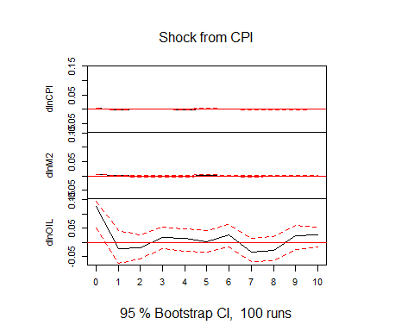

plot(irf_M2, main="Shock from M2")

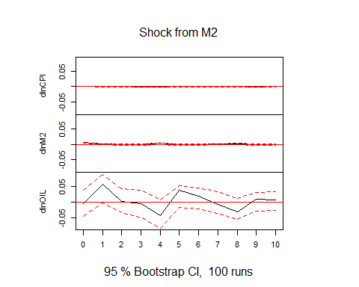

plot(irf_OIL, main="Shock from OIL")

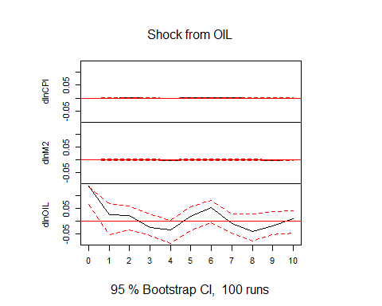

#Variance Decomposition  
fevd(var1, n.hat=4)

## $dlnCPI  
## dlnCPI dlnM2 dlnOIL  
## [1,] 1.0000000 0.000000e+00 0.000000000  
## [2,] 0.9912380 2.900723e-05 0.008732962  
## [3,] 0.9004043 8.730727e-03 0.090864964  
## [4,] 0.8876755 1.984720e-02 0.092477253  
## [5,] 0.6975439 2.794719e-02 0.274508876  
## [6,] 0.7011187 2.605331e-02 0.272827951  
## [7,] 0.6775622 3.838238e-02 0.284055459  
## [8,] 0.6808052 3.740881e-02 0.281786028  
## [9,] 0.6843159 3.716476e-02 0.278519367  
## [10,] 0.6631698 4.537758e-02 0.291452581  
##   
## $dlnM2  
## dlnCPI dlnM2 dlnOIL  
## [1,] 0.1822136 0.8177864 0.000000000  
## [2,] 0.1839643 0.8109258 0.005109807  
## [3,] 0.2059293 0.7778590 0.016211708  
## [4,] 0.2179224 0.7403782 0.041699400  
## [5,] 0.1754827 0.6827401 0.141777258  
## [6,] 0.1771317 0.6580390 0.164829326  
## [7,] 0.1764637 0.6560817 0.167454588  
## [8,] 0.1855861 0.6512975 0.163116414  
## [9,] 0.1798256 0.6602887 0.159885621  
## [10,] 0.1707583 0.6369449 0.192296777  
##   
## $dlnOIL  
## dlnCPI dlnM2 dlnOIL  
## [1,] 0.4584468 0.000695622 0.5408576  
## [2,] 0.4164857 0.088011640 0.4955026  
## [3,] 0.4167132 0.086197521 0.4970893  
## [4,] 0.4153968 0.085137749 0.4994655  
## [5,] 0.3894090 0.120113153 0.4904778  
## [6,] 0.3743276 0.146899598 0.4787728  
## [7,] 0.3582945 0.143190494 0.4985150  
## [8,] 0.3709806 0.140824103 0.4881953  
## [9,] 0.3636524 0.149743654 0.4866040  
## [10,] 0.3676542 0.148799077 0.4835468

#Forecast  
FevdSeries=predict(var1, n.head=8, ci=0.95)  
FevdSeries

## $dlnCPI  
## fcst lower upper CI  
## [1,] 7.020458e-03 0.001079042 0.012961875 0.005941417  
## [2,] -2.898372e-04 -0.007825011 0.007245337 0.007535174  
## [3,] -9.186963e-03 -0.017094085 -0.001279840 0.007907122  
## [4,] 3.453515e-05 -0.007939364 0.008008434 0.007973899  
## [5,] 6.128547e-03 -0.003438122 0.015695215 0.009566668  
## [6,] 2.316057e-03 -0.007631896 0.012264010 0.009947953  
## [7,] -9.522986e-04 -0.011269749 0.009365152 0.010317451  
## [8,] -4.363180e-03 -0.014884182 0.006157822 0.010521002  
## [9,] -3.025447e-03 -0.013624624 0.007573729 0.010599177  
## [10,] 4.002124e-03 -0.006804225 0.014808474 0.010806349  
##   
## $dlnM2  
## fcst lower upper CI  
## [1,] 0.04621349 0.029157722 0.06326925 0.01705576  
## [2,] 0.03071732 0.013524681 0.04790995 0.01719263  
## [3,] 0.02515523 0.007533717 0.04277674 0.01762151  
## [4,] 0.03579834 0.017712446 0.05388424 0.01808589  
## [5,] 0.04271164 0.021983172 0.06344011 0.02072847  
## [6,] 0.03785028 0.016671709 0.05902885 0.02117857  
## [7,] 0.03492612 0.013665569 0.05618666 0.02126055  
## [8,] 0.03173471 0.010182259 0.05328716 0.02155245  
## [9,] 0.03122497 0.008928948 0.05352100 0.02229603  
## [10,] 0.03705855 0.014168918 0.05994818 0.02288963  
##   
## $dlnOIL  
## fcst lower upper CI  
## [1,] -0.0904452509 -0.4562782 0.2753877 0.3658329  
## [2,] -0.0931250074 -0.4822696 0.2960196 0.3891446  
## [3,] -0.2183708461 -0.6117679 0.1750262 0.3933970  
## [4,] -0.0002819566 -0.3980958 0.3975319 0.3978139  
## [5,] 0.2276750463 -0.1852617 0.6406118 0.4129368  
## [6,] 0.0180157169 -0.4032439 0.4392753 0.4212596  
## [7,] -0.2397647627 -0.6786967 0.1991672 0.4389319  
## [8,] -0.1658537742 -0.6101704 0.2784629 0.4443167  
## [9,] 0.0271000382 -0.4308624 0.4850624 0.4579624  
## [10,] 0.1559213806 -0.3062870 0.6181298 0.4622084

fanchart(FevdSeries, names="dlnCPI")

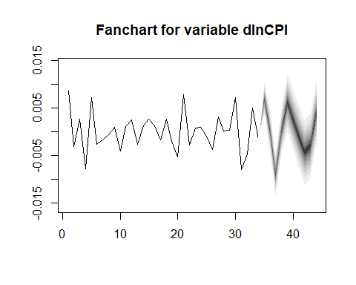

fanchart(FevdSeries, names="dlnM2")

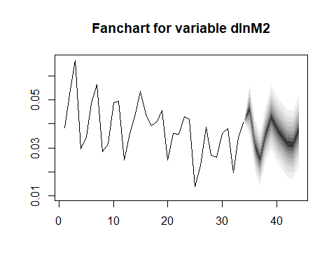

fanchart(FevdSeries, names="dlnOIL")

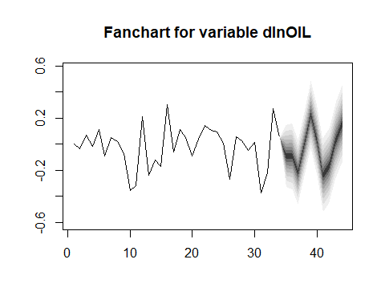 Uoc luong mo hinh VECM

#Tu ket qua kiem dinh tinh dung, ta uoc luong mo hinh VECM voi cac bien: inf, log(ex), log(CPI), log(PWTI)  
lnCPI<-log(CPI)  
lnEX<-log(EX)  
lnOIL=log(OIL)  
lnM2=log(M2)  
Series2=cbind(lnCPI,lnM2,lnEX,lnOIL)  
VARselect(Series2, lag.max = 20, type = "const") #chon lag 4

## Warning in log(sigma.det): NaNs produced  
  
## Warning in log(sigma.det): NaNs produced  
  
## Warning in log(sigma.det): NaNs produced

## $selection  
## AIC(n) HQ(n) SC(n) FPE(n)   
## 4 4 4 3   
##   
## $criteria  
## 1 2 3 4 5 6 7 8 9  
## AIC(n) -3.558021e+01 -3.752652e+01 NaN -Inf -Inf -Inf -Inf -Inf -Inf  
## HQ(n) -3.559027e+01 -3.754462e+01 NaN -Inf -Inf -Inf -Inf -Inf -Inf  
## SC(n) -3.463614e+01 -3.582720e+01 NaN -Inf -Inf -Inf -Inf -Inf -Inf  
## FPE(n) 3.923854e-16 1.061854e-16 -2.365227e-46 0 0 0 0 0 0  
## 10 11 12 13 14 15 16 17 18 19 20  
## AIC(n) -Inf -Inf -Inf -Inf -Inf -Inf -Inf -Inf -Inf -Inf -Inf  
## HQ(n) -Inf -Inf -Inf -Inf -Inf -Inf -Inf -Inf -Inf -Inf -Inf  
## SC(n) -Inf -Inf -Inf -Inf -Inf -Inf -Inf -Inf -Inf -Inf -Inf  
## FPE(n) 0 0 0 0 0 0 0 0 0 0 0

#Kiem tra so quan he dong tich hop (r=3)  
ctest1tr=ca.jo(Series2, type="trace", ecdet="trend", K=4)  
summary(ctest1tr)

##   
## ######################   
## # Johansen-Procedure #   
## ######################   
##   
## Test type: trace statistic , with linear trend in cointegration   
##   
## Eigenvalues (lambda):  
## [1] 8.817467e-01 7.442167e-01 4.417879e-01 2.402830e-01 2.220446e-16  
##   
## Values of teststatistic and critical values of test:  
##   
## test 10pct 5pct 1pct  
## r <= 3 | 8.52 10.49 12.25 16.26  
## r <= 2 | 26.59 22.76 25.32 30.45  
## r <= 1 | 68.86 39.06 42.44 48.45  
## r = 0 | 135.04 59.14 62.99 70.05  
##   
## Eigenvectors, normalised to first column:  
## (These are the cointegration relations)  
##   
## lnCPI.l4 lnM2.l4 lnEX.l4 lnOIL.l4 trend.l4  
## lnCPI.l4 1.000000000 1.000000000 1.0000000000 1.00000000 1.000000000  
## lnM2.l4 0.050938388 0.042941034 -0.0474459903 0.42496837 0.172796386  
## lnEX.l4 0.041501532 -0.169074972 0.2621827691 -0.29389872 0.698792347  
## lnOIL.l4 0.005550188 -0.005006858 -0.0085860032 -0.02389292 0.022236884  
## trend.l4 -0.001778656 -0.001162749 0.0002872193 -0.01559178 -0.009877174  
##   
## Weights W:  
## (This is the loading matrix)  
##   
## lnCPI.l4 lnM2.l4 lnEX.l4 lnOIL.l4 trend.l4  
## lnCPI.d -1.3105117 -1.364266 -0.05056333 0.07398808 4.717913e-10  
## lnM2.d -4.9926753 3.870078 0.87103544 -0.01583478 -1.413603e-09  
## lnEX.d 0.4061381 1.345138 -1.58811879 0.20841510 -2.000146e-09  
## lnOIL.d 12.9596857 -35.563373 22.24820899 5.93184177 2.305193e-08

ctest1eg=ca.jo(Series2, type="eigen", ecdet="trend", K=4)  
summary(ctest1eg)

##   
## ######################   
## # Johansen-Procedure #   
## ######################   
##   
## Test type: maximal eigenvalue statistic (lambda max) , with linear trend in cointegration   
##   
## Eigenvalues (lambda):  
## [1] 8.817467e-01 7.442167e-01 4.417879e-01 2.402830e-01 2.220446e-16  
##   
## Values of teststatistic and critical values of test:  
##   
## test 10pct 5pct 1pct  
## r <= 3 | 8.52 10.49 12.25 16.26  
## r <= 2 | 18.07 16.85 18.96 23.65  
## r <= 1 | 42.27 23.11 25.54 30.34  
## r = 0 | 66.18 29.12 31.46 36.65  
##   
## Eigenvectors, normalised to first column:  
## (These are the cointegration relations)  
##   
## lnCPI.l4 lnM2.l4 lnEX.l4 lnOIL.l4 trend.l4  
## lnCPI.l4 1.000000000 1.000000000 1.0000000000 1.00000000 1.000000000  
## lnM2.l4 0.050938388 0.042941034 -0.0474459903 0.42496837 0.172796386  
## lnEX.l4 0.041501532 -0.169074972 0.2621827691 -0.29389872 0.698792347  
## lnOIL.l4 0.005550188 -0.005006858 -0.0085860032 -0.02389292 0.022236884  
## trend.l4 -0.001778656 -0.001162749 0.0002872193 -0.01559178 -0.009877174  
##   
## Weights W:  
## (This is the loading matrix)  
##   
## lnCPI.l4 lnM2.l4 lnEX.l4 lnOIL.l4 trend.l4  
## lnCPI.d -1.3105117 -1.364266 -0.05056333 0.07398808 4.717913e-10  
## lnM2.d -4.9926753 3.870078 0.87103544 -0.01583478 -1.413603e-09  
## lnEX.d 0.4061381 1.345138 -1.58811879 0.20841510 -2.000146e-09  
## lnOIL.d 12.9596857 -35.563373 22.24820899 5.93184177 2.305193e-08

#Uoc luong VECM  
VECM1= VECM(Series2, lag=4, r=3, include = c("both"), LRinclude = c("const"), estim ="ML")  
summary(VECM1)

## Warning in if (class(x) == "numeric") return(noquote(r)): the condition has  
## length > 1 and only the first element will be used

## Warning in if (class(x) == "matrix") return(matrix(noquote(r), ncol = ncol(x), :  
## the condition has length > 1 and only the first element will be used

## Warning in if (class(x) == "numeric") return(noquote(r)): the condition has  
## length > 1 and only the first element will be used

## Warning in if (class(x) == "matrix") return(matrix(noquote(r), ncol = ncol(x), :  
## the condition has length > 1 and only the first element will be used

## #############  
## ###Model VECM   
## #############  
## Full sample size: 35 End sample size: 30  
## Number of variables: 4 Number of estimated slope parameters 76  
## AIC -1113.699 BIC -1003.005 SSR 0.3459872  
## Cointegrating vector (estimated by ML):  
## lnCPI lnM2 lnEX lnOIL const  
## r1 1.000000e+00 -1.734723e-18 0.000000e+00 -0.002907096 -4.596203  
## r2 -8.881784e-16 1.000000e+00 -1.776357e-15 0.605280625 -19.828873  
## r3 8.673617e-17 1.734723e-18 1.000000e+00 0.068062342 -10.470291  
##   
##   
## ECT1 ECT2 ECT3   
## Equation lnCPI -1.8832(0.5490)** -0.0504(0.0135)** 0.4735(0.1487)**   
## Equation lnM2 1.7595(1.9509) -0.0043(0.0480) -0.9292(0.5286)   
## Equation lnEX -5.9801(2.2228)* -0.0281(0.0547) 0.7325(0.6022)   
## Equation lnOIL -3.4195(58.8133) -2.3005(1.4464) 18.8459(15.9347)   
## lnCPI -1 lnM2 -1 lnEX -1   
## Equation lnCPI 0.7337(0.4116) 0.0626(0.1037) -0.5330(0.1102)***   
## Equation lnM2 -0.9058(1.4628) -1.1887(0.3685)** 0.0548(0.3917)   
## Equation lnEX 5.1692(1.6667)* 0.7784(0.4198). -0.3874(0.4463)   
## Equation lnOIL -22.2759(44.0985) 6.3227(11.1079) -19.1495(11.8082)   
## lnOIL -1 lnCPI -2 lnM2 -2   
## Equation lnCPI -0.0090(0.0068) 0.1772(0.3689) 0.1243(0.1250)   
## Equation lnM2 0.0639(0.0240)* 0.5298(1.3109) -1.2604(0.4441)*   
## Equation lnEX -0.0391(0.0274) 3.8900(1.4937)* 0.6427(0.5060)   
## Equation lnOIL 0.0902(0.7238) -36.7954(39.5208) -1.7130(13.3878)   
## lnEX -2 lnOIL -2 lnCPI -3   
## Equation lnCPI -0.2845(0.1185)* -0.0012(0.0056) -0.0026(0.3278)   
## Equation lnM2 0.0532(0.4211) 0.0519(0.0200)* 0.9570(1.1649)   
## Equation lnEX -0.5141(0.4798) -0.0400(0.0228) 2.1527(1.3273)   
## Equation lnOIL -8.7987(12.6944) -0.0125(0.6044) -23.8116(35.1198)   
## lnM2 -3 lnEX -3 lnOIL -3   
## Equation lnCPI 0.0224(0.0896) -0.1907(0.0992). -0.0055(0.0055)   
## Equation lnM2 -0.7994(0.3184)* 0.3454(0.3526) 0.0359(0.0195).   
## Equation lnEX 0.6805(0.3627). -0.2795(0.4017) -0.0385(0.0222)   
## Equation lnOIL -2.3862(9.5975) -12.8376(10.6298) -0.1484(0.5872)   
## lnCPI -4 lnM2 -4 lnEX -4   
## Equation lnCPI 0.0768(0.2037) -0.0340(0.0893) -0.2884(0.1024)*   
## Equation lnM2 0.5461(0.7238) -0.3103(0.3173) 0.0657(0.3639)   
## Equation lnEX 0.9121(0.8247) 0.3557(0.3615) -0.8693(0.4146).   
## Equation lnOIL -0.7507(21.8202) -7.6892(9.5650) -7.1485(10.9701)   
## lnOIL -4   
## Equation lnCPI -0.0096(0.0038)*   
## Equation lnM2 0.0036(0.0136)   
## Equation lnEX -0.0014(0.0155)   
## Equation lnOIL 0.0047(0.4097)

#Bien doi thanh VAR  
VECM2VAR=vec2var(ctest1tr,r=3)  
VECM2VAR

##   
## Coefficient matrix of lagged endogenous variables:  
##   
## A1:  
## lnCPI.l1 lnM2.l1 lnEX.l1 lnOIL.l1  
## lnCPI -0.3398455 -0.11626883 -0.1395629 0.002277265  
## lnM2 0.4758018 0.05135768 -0.7742163 -0.007164939  
## lnEX 0.9055239 0.21554444 0.8612055 0.003577427  
## lnOIL -18.7773534 3.85483914 -4.3696551 1.012595877  
##   
##   
## A2:  
## lnCPI.l2 lnM2.l2 lnEX.l2 lnOIL.l2  
## lnCPI -0.714106619 0.15979280 0.21325668 0.010003755  
## lnM2 0.339620030 0.09908362 0.15360835 0.001247821  
## lnEX 0.009912017 0.18994978 -0.02864037 0.001602548  
## lnOIL -14.292260929 -1.52388922 14.89621986 -0.018605078  
##   
##   
## A3:  
## lnCPI.l3 lnM2.l3 lnEX.l3 lnOIL.l3  
## lnCPI -0.4538358 -0.1389857 0.04976936 -0.000311831  
## lnM2 -0.3687472 0.1994348 0.28902067 -0.015356218  
## lnEX -0.4076907 -0.0833372 -0.14618647 -0.005915935  
## lnOIL 17.7517392 -3.7696955 -5.23670733 -0.191051172  
##   
##   
## A4:  
## lnCPI.l4 lnM2.l4 lnEX.l4 lnOIL.l4  
## lnCPI -0.2175535 -0.02747756 0.03955514 -0.01197795  
## lnM2 -0.6982363 0.52066305 -0.30157927 -0.03329260  
## lnEX -0.3445876 -0.16835750 -0.31332990 0.00989078  
## lnOIL 14.9623970 -0.48382523 7.09396263 0.25602663  
##   
##   
## Coefficient matrix of deterministic regressor(s).  
##   
## constant trend.l4  
## lnCPI 12.791515 0.003902726  
## lnM2 9.801389 0.004630499  
## lnEX 3.093131 -0.002742577  
## lnOIL -93.103023 0.024690574

#Kiem dinh phan du  
VECM2VARresiduals = resid(VECM2VAR)  
VECM2VARresiduals

## resids of lnCPI resids of lnM2 resids of lnEX resids of lnOIL  
## [1,] -2.536845e-03 -0.0012509320 -0.0008698209 -0.125218510  
## [2,] 9.345111e-04 0.0005281985 0.0042858663 -0.031496075  
## [3,] 7.942635e-04 0.0010432222 -0.0048051066 -0.052658105  
## [4,] 2.863569e-04 0.0024462367 -0.0033407290 0.106061630  
## [5,] -5.065523e-04 -0.0041919615 -0.0034547890 0.021706189  
## [6,] -1.267122e-03 0.0016076520 -0.0088413136 -0.087722728  
## [7,] -4.525516e-03 -0.0011140935 -0.0022199910 -0.179050527  
## [8,] -2.842688e-04 0.0052211198 -0.0018605167 -0.161269167  
## [9,] 2.458444e-03 -0.0020823079 0.0040010950 0.186800762  
## [10,] 1.365210e-03 -0.0008357342 0.0083282767 0.008627677  
## [11,] 1.261932e-03 -0.0039964966 0.0031837021 0.120895081  
## [12,] -2.218864e-03 0.0004912608 -0.0047133397 -0.179992547  
## [13,] 4.294023e-04 0.0044795552 -0.0022366328 0.129122669  
## [14,] -6.673928e-04 0.0019987599 -0.0039408337 -0.070160880  
## [15,] 9.154052e-04 -0.0033411996 0.0111579907 0.008720443  
## [16,] 2.055157e-03 0.0032618622 0.0055191118 0.207940821  
## [17,] -7.252704e-04 -0.0005779930 -0.0039830517 -0.155260714  
## [18,] 1.758372e-04 -0.0059229207 0.0027847287 -0.028028080  
## [19,] 6.438334e-04 -0.0035206396 -0.0001359464 0.122283728  
## [20,] 1.664892e-03 -0.0017901636 0.0006335382 0.200099071  
## [21,] 1.822622e-03 0.0094887317 -0.0018613474 0.161093561  
## [22,] 1.464064e-03 -0.0028797600 0.0099015070 0.072707703  
## [23,] -1.726724e-03 0.0017971360 -0.0074404027 0.012557541  
## [24,] 4.924419e-04 0.0040789185 0.0021377340 0.013406823  
## [25,] 8.307786e-04 -0.0053696736 0.0100006223 -0.031853662  
## [26,] -1.931639e-03 0.0036639219 -0.0043482518 -0.080120171  
## [27,] 1.554941e-03 -0.0029897020 0.0005868087 0.024976417  
## [28,] -3.135388e-04 -0.0009944563 0.0013731790 -0.157487943  
## [29,] -1.083844e-03 -0.0024998514 -0.0039183596 -0.093145632  
## [30,] -7.328403e-05 0.0023671604 -0.0010235157 0.094287452  
## [31,] -1.292484e-03 0.0008774099 -0.0048875732 -0.057807117

acf(VECM2VARresiduals[,"resids of lnCPI"])

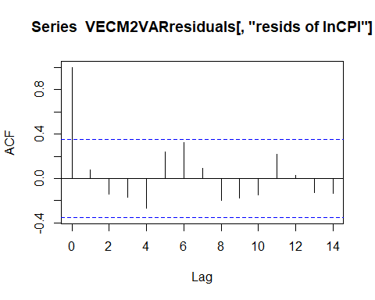

acf(VECM2VARresiduals[,"resids of lnM2"])

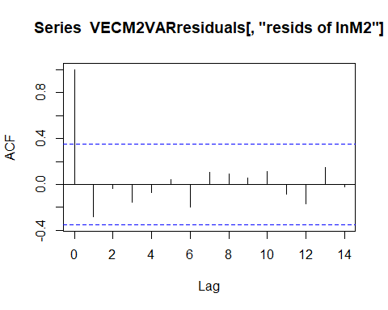

acf(VECM2VARresiduals[,"resids of lnEX"])

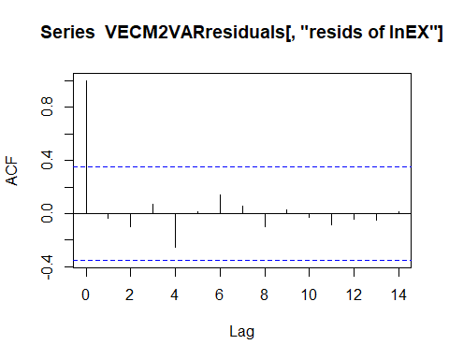

acf(VECM2VARresiduals[,"resids of lnOIL"])

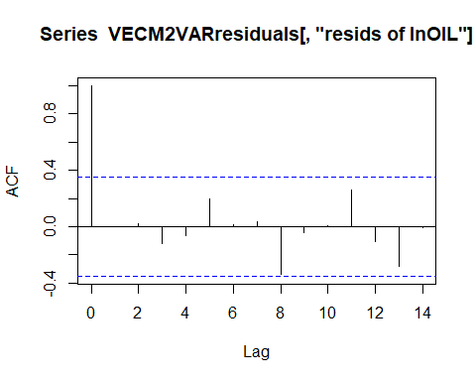

#IRF  
irfCPI=irf(VECM2VAR, impulse="lnCPI", n.ahead=10)   
irfCPI

##   
## Impulse response coefficients  
## $lnCPI  
## lnCPI lnM2 lnEX lnOIL  
## [1,] 1.532245e-03 -0.000161642 0.0029695837 0.08596793  
## [2,] -7.206049e-04 -0.002194311 0.0042176095 0.04468009  
## [3,] 3.864205e-04 -0.002973241 0.0027037732 0.05286892  
## [4,] 9.158425e-04 -0.003258606 0.0001996377 0.09447534  
## [5,] 1.961784e-04 -0.004795871 -0.0009019768 0.13427272  
## [6,] 9.402306e-04 -0.004444659 -0.0024963502 0.13627359  
## [7,] 5.894624e-04 -0.005978243 -0.0030837587 0.15206342  
## [8,] -2.200752e-05 -0.007956138 -0.0026495126 0.12846976  
## [9,] -4.483750e-04 -0.010843911 -0.0024584003 0.11704658  
## [10,] 3.640346e-05 -0.012138780 -0.0033081129 0.11995809  
## [11,] 4.043938e-04 -0.012336717 -0.0032366274 0.12028284  
##   
##   
## Lower Band, CI= 0.95   
## $lnCPI  
## lnCPI lnM2 lnEX lnOIL  
## [1,] 5.941629e-04 -0.001437820 0.0002863484 0.022994151  
## [2,] -1.013865e-03 -0.003161438 -0.0001630409 -0.020676908  
## [3,] -2.976667e-04 -0.003697195 -0.0013662234 -0.016758729  
## [4,] -8.994412e-05 -0.004224369 -0.0024620179 -0.006757236  
## [5,] -7.864911e-04 -0.006137577 -0.0036555773 -0.004206699  
## [6,] -2.534880e-04 -0.006537193 -0.0047321699 -0.003837758  
## [7,] -5.449392e-04 -0.007780698 -0.0051677665 -0.013534190  
## [8,] -8.226760e-04 -0.009838425 -0.0046309031 -0.043112284  
## [9,] -1.030255e-03 -0.013258945 -0.0049210535 -0.026775953  
## [10,] -7.856118e-04 -0.014457607 -0.0056101310 -0.041552242  
## [11,] -8.030163e-04 -0.014752281 -0.0053983038 -0.025844889  
##   
##   
## Upper Band, CI= 0.95   
## $lnCPI  
## lnCPI lnM2 lnEX lnOIL  
## [1,] 1.441987e-03 1.256600e-03 0.0036758916 0.08779445  
## [2,] -6.282329e-05 4.733186e-04 0.0047506264 0.06707288  
## [3,] 9.424096e-04 4.300258e-04 0.0043952390 0.08321811  
## [4,] 1.311255e-03 3.589153e-04 0.0025428740 0.11272510  
## [5,] 6.236292e-04 -2.878564e-04 0.0019543751 0.16519555  
## [6,] 1.588446e-03 9.558185e-04 0.0007498656 0.17919923  
## [7,] 9.924974e-04 6.022987e-05 0.0012218407 0.18287509  
## [8,] 7.144071e-04 -8.461540e-04 0.0015893976 0.18844126  
## [9,] 5.186885e-04 -8.555874e-04 0.0015941052 0.20627205  
## [10,] 9.791804e-04 -5.677454e-04 0.0014249637 0.24711352  
## [11,] 1.369853e-03 1.604136e-04 0.0018436240 0.23089838

plot(irfCPI, main="Shock from CPI")

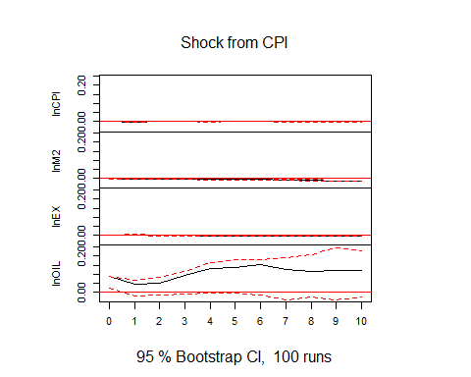

irfEX=irf(VECM2VAR, impulse="lnEX", n.ahead=10)   
irfEX

##   
## Impulse response coefficients  
## $lnEX  
## lnCPI lnM2 lnEX lnOIL  
## [1,] 0.000000e+00 0.0000000000 0.0035986682 -0.01128237  
## [2,] -5.279337e-04 -0.0027053101 0.0030588310 -0.02714942  
## [3,] 6.598072e-04 -0.0020250960 0.0013548381 0.01244370  
## [4,] 3.585289e-04 0.0002738169 0.0002627323 0.02753284  
## [5,] 5.447769e-04 0.0002774949 -0.0007735693 0.04729663  
## [6,] 7.983924e-04 -0.0007481283 -0.0008131977 0.05800530  
## [7,] -3.549096e-04 -0.0020542868 -0.0003331850 0.04614698  
## [8,] -5.157520e-04 -0.0024016277 -0.0012955581 0.04125040  
## [9,] 4.854248e-06 -0.0031255473 -0.0022747747 0.07504690  
## [10,] 5.065694e-04 -0.0032120646 -0.0019470120 0.08051929  
## [11,] 4.773854e-04 -0.0031115969 -0.0006458407 0.04149536  
##   
##   
## Lower Band, CI= 0.95   
## $lnEX  
## lnCPI lnM2 lnEX lnOIL  
## [1,] 0.000000e+00 0.000000000 0.0014012157 -0.03851846  
## [2,] -7.508567e-04 -0.002834639 0.0001044038 -0.07465078  
## [3,] -1.775637e-04 -0.002593250 -0.0008351682 -0.06198738  
## [4,] -4.562274e-04 -0.001439214 -0.0014095247 -0.05758455  
## [5,] -3.798263e-04 -0.001777961 -0.0021327745 -0.04299999  
## [6,] -1.799875e-05 -0.002825488 -0.0019319549 -0.04069658  
## [7,] -8.722933e-04 -0.003773748 -0.0022127764 -0.07799059  
## [8,] -1.054006e-03 -0.003839839 -0.0027923309 -0.09093838  
## [9,] -7.260367e-04 -0.003866413 -0.0028557001 -0.04548870  
## [10,] -5.475545e-04 -0.005494752 -0.0024780378 -0.02941404  
## [11,] -6.570726e-04 -0.006748193 -0.0015060919 -0.03307808  
##   
##   
## Upper Band, CI= 0.95   
## $lnEX  
## lnCPI lnM2 lnEX lnOIL  
## [1,] 0.0000000000 0.0000000000 0.0028729882 0.01922095  
## [2,] 0.0000241518 -0.0006066538 0.0031316374 0.02081755  
## [3,] 0.0008702924 0.0002782556 0.0027803332 0.03915615  
## [4,] 0.0006923629 0.0016598264 0.0015997498 0.04421587  
## [5,] 0.0008501152 0.0027188817 0.0007735867 0.06025259  
## [6,] 0.0010615827 0.0033197388 0.0011347564 0.06713659  
## [7,] 0.0002330625 0.0028862154 0.0030667736 0.07464721  
## [8,] 0.0003983179 0.0025812968 0.0029936170 0.07917939  
## [9,] 0.0005335071 0.0026099875 0.0012804623 0.08117842  
## [10,] 0.0008249947 0.0041143105 0.0010062562 0.08512281  
## [11,] 0.0011612796 0.0071708783 0.0016893585 0.05030740

plot(irfEX, main="Shock from EX")

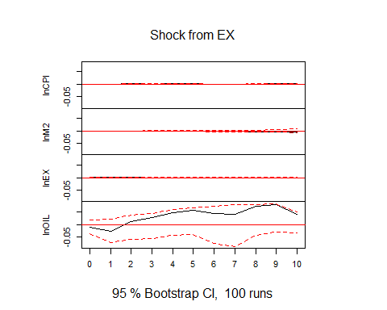

irfM2=irf(VECM2VAR, impulse="lnM2", n.ahead=10)   
irfM2

##   
## Impulse response coefficients  
## $lnM2  
## lnCPI lnM2 lnEX lnOIL  
## [1,] 0.000000e+00 0.0033977968 -1.944072e-03 0.011853244  
## [2,] -9.674441e-05 0.0015947077 -8.994655e-04 0.033595432  
## [3,] 2.964351e-04 0.0005443719 3.217717e-04 0.011555170  
## [4,] -2.871535e-04 -0.0002002613 1.016681e-03 -0.013136955  
## [5,] -5.366361e-04 0.0009171664 6.346424e-04 -0.035450578  
## [6,] -4.936506e-04 -0.0004577169 1.377842e-04 -0.005940849  
## [7,] 5.064215e-04 -0.0002043869 -4.718309e-04 0.019528981  
## [8,] 6.355681e-04 0.0015921760 -8.379207e-05 0.011570504  
## [9,] 1.750081e-04 0.0025326564 6.343682e-04 -0.027704104  
## [10,] -6.415507e-04 -0.0001052842 1.390508e-03 -0.036529872  
## [11,] -7.837681e-04 -0.0018388428 6.363396e-04 -0.014983282  
##   
##   
## Lower Band, CI= 0.95   
## $lnM2  
## lnCPI lnM2 lnEX lnOIL  
## [1,] 0.0000000000 1.460306e-03 -0.002706090 -0.02304522  
## [2,] -0.0004969953 -7.568848e-05 -0.002230109 -0.01795312  
## [3,] -0.0003438526 -6.948775e-04 -0.001647466 -0.03580397  
## [4,] -0.0007443632 -1.173362e-03 -0.001187925 -0.03468440  
## [5,] -0.0008418757 -8.763693e-04 -0.001029048 -0.04066231  
## [6,] -0.0009100926 -2.938209e-03 -0.001351331 -0.03277314  
## [7,] -0.0004058559 -2.932936e-03 -0.002739181 -0.04346900  
## [8,] -0.0002989874 -8.428331e-04 -0.003492109 -0.05310940  
## [9,] -0.0005731249 -9.240277e-04 -0.002420290 -0.06075932  
## [10,] -0.0010744236 -4.097574e-03 -0.001041877 -0.05605815  
## [11,] -0.0014165178 -6.770665e-03 -0.001162849 -0.04816029  
##   
##   
## Upper Band, CI= 0.95   
## $lnM2  
## lnCPI lnM2 lnEX lnOIL  
## [1,] 0.0000000000 0.003093028 -0.0002131628 0.03565315  
## [2,] 0.0003288875 0.002759312 0.0007727745 0.06765191  
## [3,] 0.0007635337 0.002177585 0.0017997055 0.06247363  
## [4,] 0.0003282464 0.001677536 0.0016922575 0.04770037  
## [5,] 0.0002654434 0.002683679 0.0013993376 0.03603825  
## [6,] 0.0002316913 0.003238277 0.0011406693 0.06019723  
## [7,] 0.0009508079 0.003351385 0.0011972246 0.08106452  
## [8,] 0.0011283964 0.003533976 0.0015399906 0.09306600  
## [9,] 0.0007433023 0.004612148 0.0016160080 0.05907136  
## [10,] 0.0002057336 0.005063866 0.0023202028 0.02941034  
## [11,] 0.0004650255 0.004625930 0.0018133146 0.04679534

plot(irfM2, main="Shock from M2")

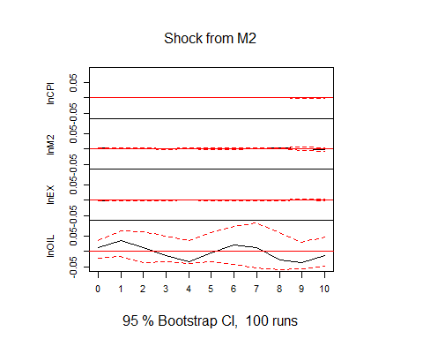

irfOIL=irf(VECM2VAR, impulse="lnOIL", n.ahead=10)   
irfOIL

##   
## Impulse response coefficients  
## $lnOIL  
## lnCPI lnM2 lnEX lnOIL  
## [1,] 0.0000000000 0.0000000000 0.0000000000 0.074409580  
## [2,] 0.0001694504 -0.0005331401 0.0002661948 0.075346834  
## [3,] 0.0008832096 -0.0005998540 0.0006565671 0.068511319  
## [4,] 0.0004150938 -0.0016127960 0.0010543360 0.034346671  
## [5,] -0.0008279752 -0.0042470448 0.0012715761 0.021237102  
## [6,] -0.0005599487 -0.0058550216 -0.0008896820 0.052100312  
## [7,] 0.0006173208 -0.0048371589 -0.0032897865 0.118509284  
## [8,] 0.0014843863 -0.0021900831 -0.0033837636 0.120702246  
## [9,] 0.0008675999 -0.0030204444 -0.0008887613 0.058992212  
## [10,] -0.0007944890 -0.0076456990 0.0013733106 -0.009582684  
## [11,] -0.0018824574 -0.0115513624 0.0004983912 -0.004545992  
##   
##   
## Lower Band, CI= 0.95   
## $lnOIL  
## lnCPI lnM2 lnEX lnOIL  
## [1,] 0.000000e+00 0.000000000 0.0000000000 0.0227066049  
## [2,] -2.889463e-04 -0.001289186 -0.0009805711 0.0069741273  
## [3,] 6.377101e-05 -0.001347922 -0.0008813924 0.0009709232  
## [4,] -2.758194e-04 -0.002238393 -0.0008266209 -0.0100357693  
## [5,] -1.030676e-03 -0.004247177 -0.0007075428 -0.0154129016  
## [6,] -7.533588e-04 -0.005513786 -0.0020815768 -0.0062294768  
## [7,] -1.703692e-04 -0.004674124 -0.0038068331 0.0159804818  
## [8,] 1.837829e-04 -0.003126393 -0.0042397449 0.0102220795  
## [9,] -9.196727e-05 -0.003891065 -0.0021677015 -0.0204748243  
## [10,] -1.072623e-03 -0.008008417 -0.0004688184 -0.0610287598  
## [11,] -1.999742e-03 -0.011583295 -0.0010524672 -0.0546300601  
##   
##   
## Upper Band, CI= 0.95   
## $lnOIL  
## lnCPI lnM2 lnEX lnOIL  
## [1,] 0.000000e+00 0.0000000000 0.0000000000 0.06309692  
## [2,] 4.070644e-04 0.0002262953 0.0010025812 0.07603987  
## [3,] 9.335283e-04 0.0005673666 0.0015189839 0.07431352  
## [4,] 6.190949e-04 0.0003057609 0.0016291858 0.06027523  
## [5,] -6.413218e-05 -0.0006669583 0.0017196941 0.04850722  
## [6,] 1.782264e-04 -0.0009321856 0.0002450029 0.06664176  
## [7,] 8.480074e-04 0.0000145024 -0.0006038013 0.12483194  
## [8,] 1.438933e-03 0.0011632882 -0.0004647015 0.13998563  
## [9,] 9.226787e-04 0.0006540348 0.0010028032 0.09586583  
## [10,] -3.762107e-05 -0.0003561476 0.0024908516 0.04441371  
## [11,] -4.497799e-04 -0.0014855658 0.0016140443 0.03441640

plot(irfOIL, main="Shock from OIL")

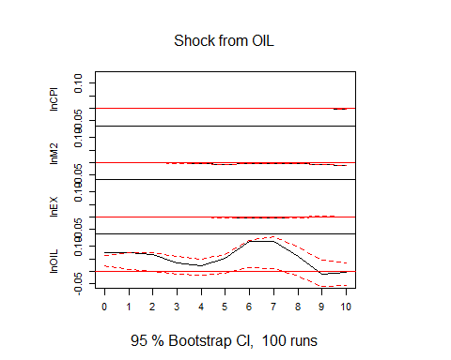

#Variance Decomposition  
fevd(VECM2VAR)

## $lnCPI  
## lnCPI lnM2 lnEX lnOIL  
## [1,] 1.0000000 0.000000000 0.00000000 0.000000000  
## [2,] 0.9005015 0.002939688 0.08754035 0.009018504  
## [3,] 0.6505794 0.020971562 0.15401050 0.174438514  
## [4,] 0.6580410 0.030671722 0.14382552 0.167461766  
## [5,] 0.5432486 0.065250390 0.15896997 0.232531067  
## [6,] 0.5167273 0.076937086 0.19217137 0.214164281  
## [7,] 0.4948478 0.093446519 0.18371941 0.227986280  
## [8,] 0.3873996 0.103679990 0.16391872 0.345001733  
## [9,] 0.3747143 0.098654605 0.15256881 0.374062314  
## [10,] 0.3433865 0.116910872 0.15631725 0.383385345  
##   
## $lnM2  
## lnCPI lnM2 lnEX lnOIL  
## [1,] 0.00225804 0.99774196 0.00000000 0.00000000  
## [2,] 0.18246254 0.53098208 0.27584242 0.01071296  
## [3,] 0.34092835 0.35845066 0.28457139 0.01604961  
## [4,] 0.45450583 0.26979834 0.21499779 0.06069804  
## [5,] 0.49570409 0.15998453 0.12127093 0.22304045  
## [6,] 0.44636297 0.10301342 0.08075445 0.36986916  
## [7,] 0.48119158 0.07263678 0.07654293 0.36962871  
## [8,] 0.57269203 0.06224322 0.07626701 0.28879773  
## [9,] 0.65528092 0.05651467 0.07365852 0.21454589  
## [10,] 0.66409486 0.03771242 0.06502625 0.23316647  
##   
## $lnEX  
## lnCPI lnM2 lnEX lnOIL  
## [1,] 0.3451675 0.14793249 0.5069000 0.000000000  
## [2,] 0.4966446 0.08564893 0.4163838 0.001322679  
## [3,] 0.5362089 0.07417768 0.3816781 0.007935381  
## [4,] 0.5183660 0.08740413 0.3695981 0.024631724  
## [5,] 0.5043640 0.08889574 0.3598805 0.046859686  
## [6,] 0.5349783 0.08020829 0.3323362 0.052477267  
## [7,] 0.5190882 0.06546190 0.2628972 0.152552656  
## [8,] 0.4897818 0.05428928 0.2320768 0.223852114  
## [9,] 0.4895140 0.05220001 0.2497429 0.208543088  
## [10,] 0.5020533 0.05870143 0.2440643 0.195180980  
##   
## $lnOIL  
## lnCPI lnM2 lnEX lnOIL  
## [1,] 0.5600947 0.01064788 0.009646937 0.4196105  
## [2,] 0.4128920 0.05582554 0.038021163 0.4932613  
## [3,] 0.3992559 0.04597191 0.033404679 0.5213675  
## [4,] 0.5080335 0.03791456 0.042777231 0.4112747  
## [5,] 0.6161182 0.04458338 0.063195388 0.2761030  
## [6,] 0.6542302 0.03250668 0.083654791 0.2296084  
## [7,] 0.6320564 0.02540310 0.074351373 0.2681891  
## [8,] 0.6053399 0.02103656 0.069716664 0.3039069  
## [9,] 0.6022281 0.02250903 0.091347502 0.2839154  
## [10,] 0.6068756 0.02653709 0.112861429 0.2537259

#Forecast  
FevdSeries1=predict(VECM2VAR,n.ahead=8, ci=0.95)  
FevdSeries1

## $lnCPI  
## fcst lower upper CI  
## [1,] 4.626860 4.623856 4.629863 0.003003146  
## [2,] 4.618973 4.615476 4.622470 0.003497223  
## [3,] 4.599270 4.595050 4.603490 0.004220269  
## [4,] 4.595727 4.590983 4.600471 0.004743965  
## [5,] 4.608791 4.603544 4.614038 0.005247177  
## [6,] 4.628221 4.622261 4.634181 0.005959706  
## [7,] 4.633518 4.627211 4.639826 0.006307603  
## [8,] 4.609981 4.602852 4.617110 0.007129205  
##   
## $lnM2  
## fcst lower upper CI  
## [1,] 16.35231 16.34565 16.35898 0.006667091  
## [2,] 16.39601 16.38591 16.40610 0.010095658  
## [3,] 16.40785 16.39543 16.42026 0.012415955  
## [4,] 16.41978 16.40545 16.43411 0.014331108  
## [5,] 16.47797 16.45883 16.49712 0.019145568  
## [6,] 16.57434 16.55032 16.59836 0.024022609  
## [7,] 16.64161 16.61297 16.67026 0.028646671  
## [8,] 16.63985 16.60647 16.67323 0.033378393  
##   
## $lnEX  
## fcst lower upper CI  
## [1,] 10.04807 10.03817 10.05798 0.009906694  
## [2,] 10.07765 10.06331 10.09200 0.014345655  
## [3,] 10.10828 10.09269 10.12387 0.015587990  
## [4,] 10.10132 10.08545 10.11718 0.015863311  
## [5,] 10.07071 10.05444 10.08698 0.016273512  
## [6,] 10.06031 10.04315 10.07747 0.017158675  
## [7,] 10.09052 10.07119 10.10986 0.019334098  
## [8,] 10.14216 10.12091 10.16340 0.021242245  
##   
## $lnOIL  
## fcst lower upper CI  
## [1,] 3.676768 3.451627 3.901909 0.2251406  
## [2,] 3.192058 2.896537 3.487579 0.2955211  
## [3,] 2.396437 2.054079 2.738794 0.3423578  
## [4,] 2.489343 2.089839 2.888846 0.3995033  
## [5,] 3.376798 2.882819 3.870776 0.4939785  
## [6,] 3.883642 3.301542 4.465743 0.5821001  
## [7,] 3.349707 2.648804 4.050610 0.7009026  
## [8,] 2.191560 1.405631 2.977488 0.7859281

fanchart(FevdSeries1, names="lnCPI")

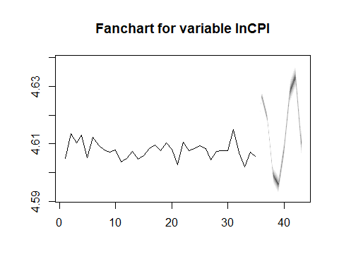

fanchart(FevdSeries1, names="lnEX")

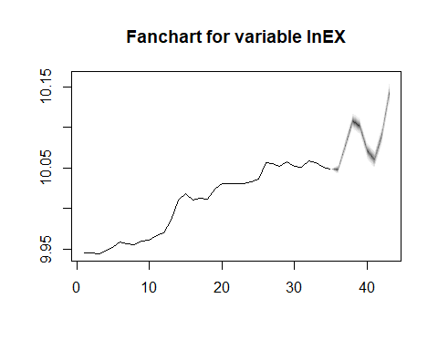

fanchart(FevdSeries1, names="lnM2")

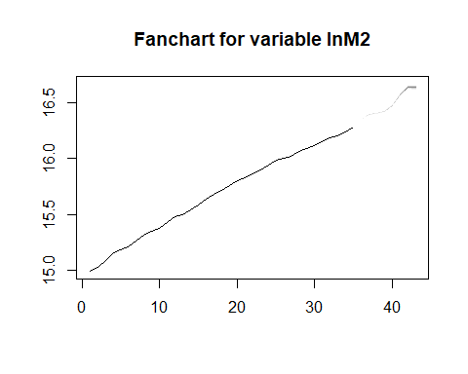

fanchart(FevdSeries1, names="lnOIL")

